CT6006 – Advanced Concepts in Languages

S1305610 – Richard Dobie

Deadline: 19/05/16

Contents

1. Introduction 3

2. Software Life Cycle 3

3. Requirements Specification 4

3.1 Software assumptions 4

3.2 Class Diagram 5

3.3 UML Use Case Diagram 5

3.4 UML Activity Diagram 5

3.5 UML Sequence Diagram 6

4. Software Design/Architecture 9

4.1 Object-oriented Programming Paradigm 11

4.2 Functional Programming Paradigm 12

4.3 Logic Programming Paradigm 12

5. Software Implementation 13

5.1 Java 13

5.2 Scala 14

5.3 Prolog 15

5.4 Code Analysis 16

5.5 Code Structure 17

5.5.1 Product Class 17

5.5.2 Product List Class 20

5.5.3 SUCatalogueGUI class 24

6. Software Deployment 25

6.1 Java Web Start 25

7. Software Testing 25

7.1 Black Box Testing 26

7.2 White Box Testing 26

7.3 Software Results and Performance 26

7.4 Big O Notation 26

8. Software Conclusions 27

9. Software Video 28

10. References 28

11. Appendix A – Software Screenshots 31

# Introduction

The software designed and created is a software which provides the ability for the University of Gloucestershire Student Union to sell University Merchandise to Students. The software created uses a Graphical User Interface to allow the student to enter or select their chosen search criteria. The software returns results to the user that match the users search criteria via the Graphical User Interface.

# Software Life Cycle

To design the software a software life cycle model was followed in order to ensure all areas of the software analysis, design and implementation are thought about and allows the creation of the software to follow a step by step method

The software life cycle used for developing this software is the waterfall method. The waterfall method shown in Figure 1 sets out six stages that need to be considered when the software is being designed, developed and maintained.

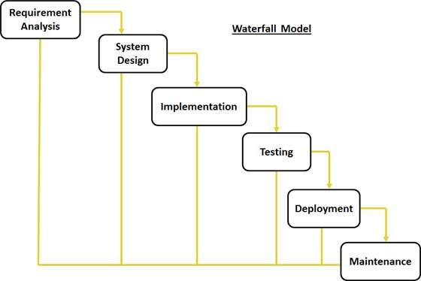

Figure - Waterfall Model Source: (tutorialspoint, 2016)

For each stage of the life cycle model the following actions were taken:

Table - Waterfall Model Stages

|  |
| --- |
| Waterfall Model Stages |
| * Requirement gathering & analysis – requirement specification (UML) * System design – object oriented / functional / logical approach * Implementation – use of three classes programmed using imperative language – Java * Testing – developed test cases * Deployment of system – software created is working and can be used * Maintenance – well-structured and commented to allow other developers or users to understand code should it be improved in the future |

# Requirements Specification

The requirements specification will detail and outline the software’s requirements and functionality based on assumptions from stakeholder analysis. The software requirements will be outlined using UML Use Case Diagrams, UML Activity Diagram and UML Sequence Diagram. The purpose of these diagrams is to provide the details regarding the software/ hardware requirements and user requirements.

## 3.1 Software assumptions

In order for the system to be developed, it is essential that the system requirements and functionality are understood as these help to influence the design of the system. To find out the systems requirements and functionality assumptions had to be made on who the system users were and how the system performs. The use of assumptions allowed a set of formal requirements to be identified. The identified assumptions for the system are shown below in Table 2.

Table - Software Assumptions

|  |
| --- |
| Software Assumptions |
| **System Users**  The system users are assumed to be University SU staff who will update the system with details regarding products they sell and University Students who will use the system to search for products they wish to purchase.  **System Inputs**  The system inputs are assumed to be the inputs that University Staff add to the system in terms of product details and University students who input data in the form of search criteria  **System Outputs**  The system outputs are assumed to be the search results which are displayed to the University Student to tell them which products match their search criteria  **System Data**  The system is assumed to use product data that is built into the system which is manually added by University SU staff  **Software Installation**  The system is assumed to be hosted on the University Student Union website to allow access to both University SU staff to update the system and University Students.  **Software priorities/ concerns**  The system is assumed to be reliable in terms of returning the correct information to University Students when searches are made  The system is assumed to be efficient in terms of time taken to return search results to the University student |

## 3.2 Class Diagram

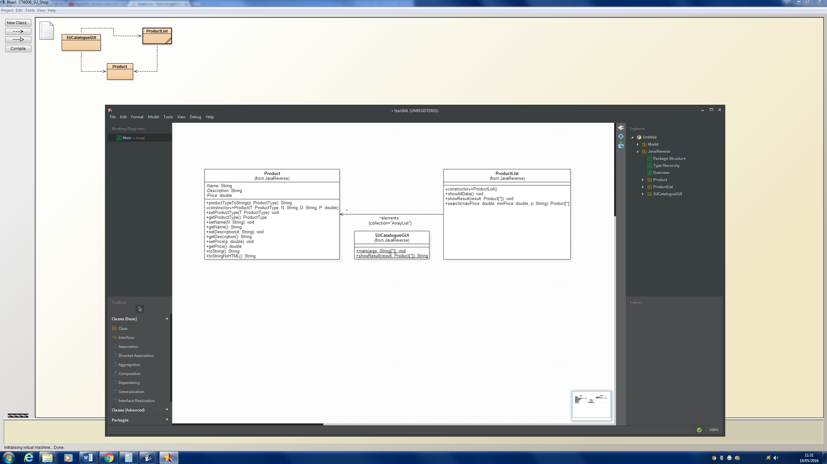

## 3.3 UML Use Case Diagram

Figure 2 shows the Use Case Diagram which is a visual representation of the interactions between the user and the system.

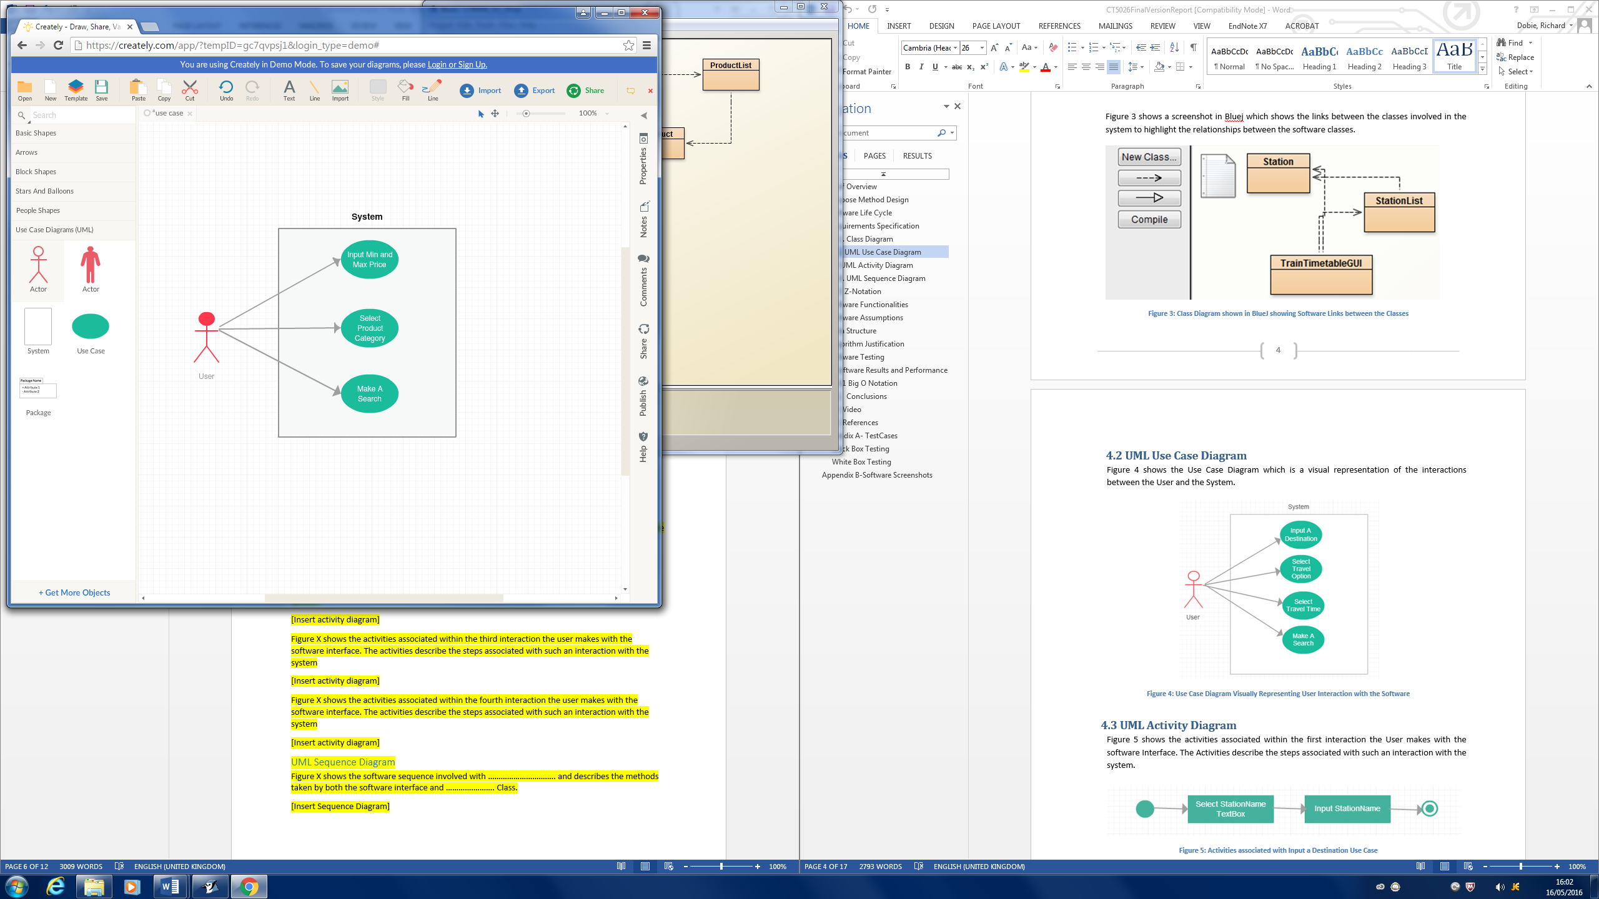

Figure 2 - Use Case Diagram

## 3.4 UML Activity Diagram

Figure 3 shows the activities associated within the first interaction the user makes with the software interface. The activities describe the steps associated with such an interaction with the system.

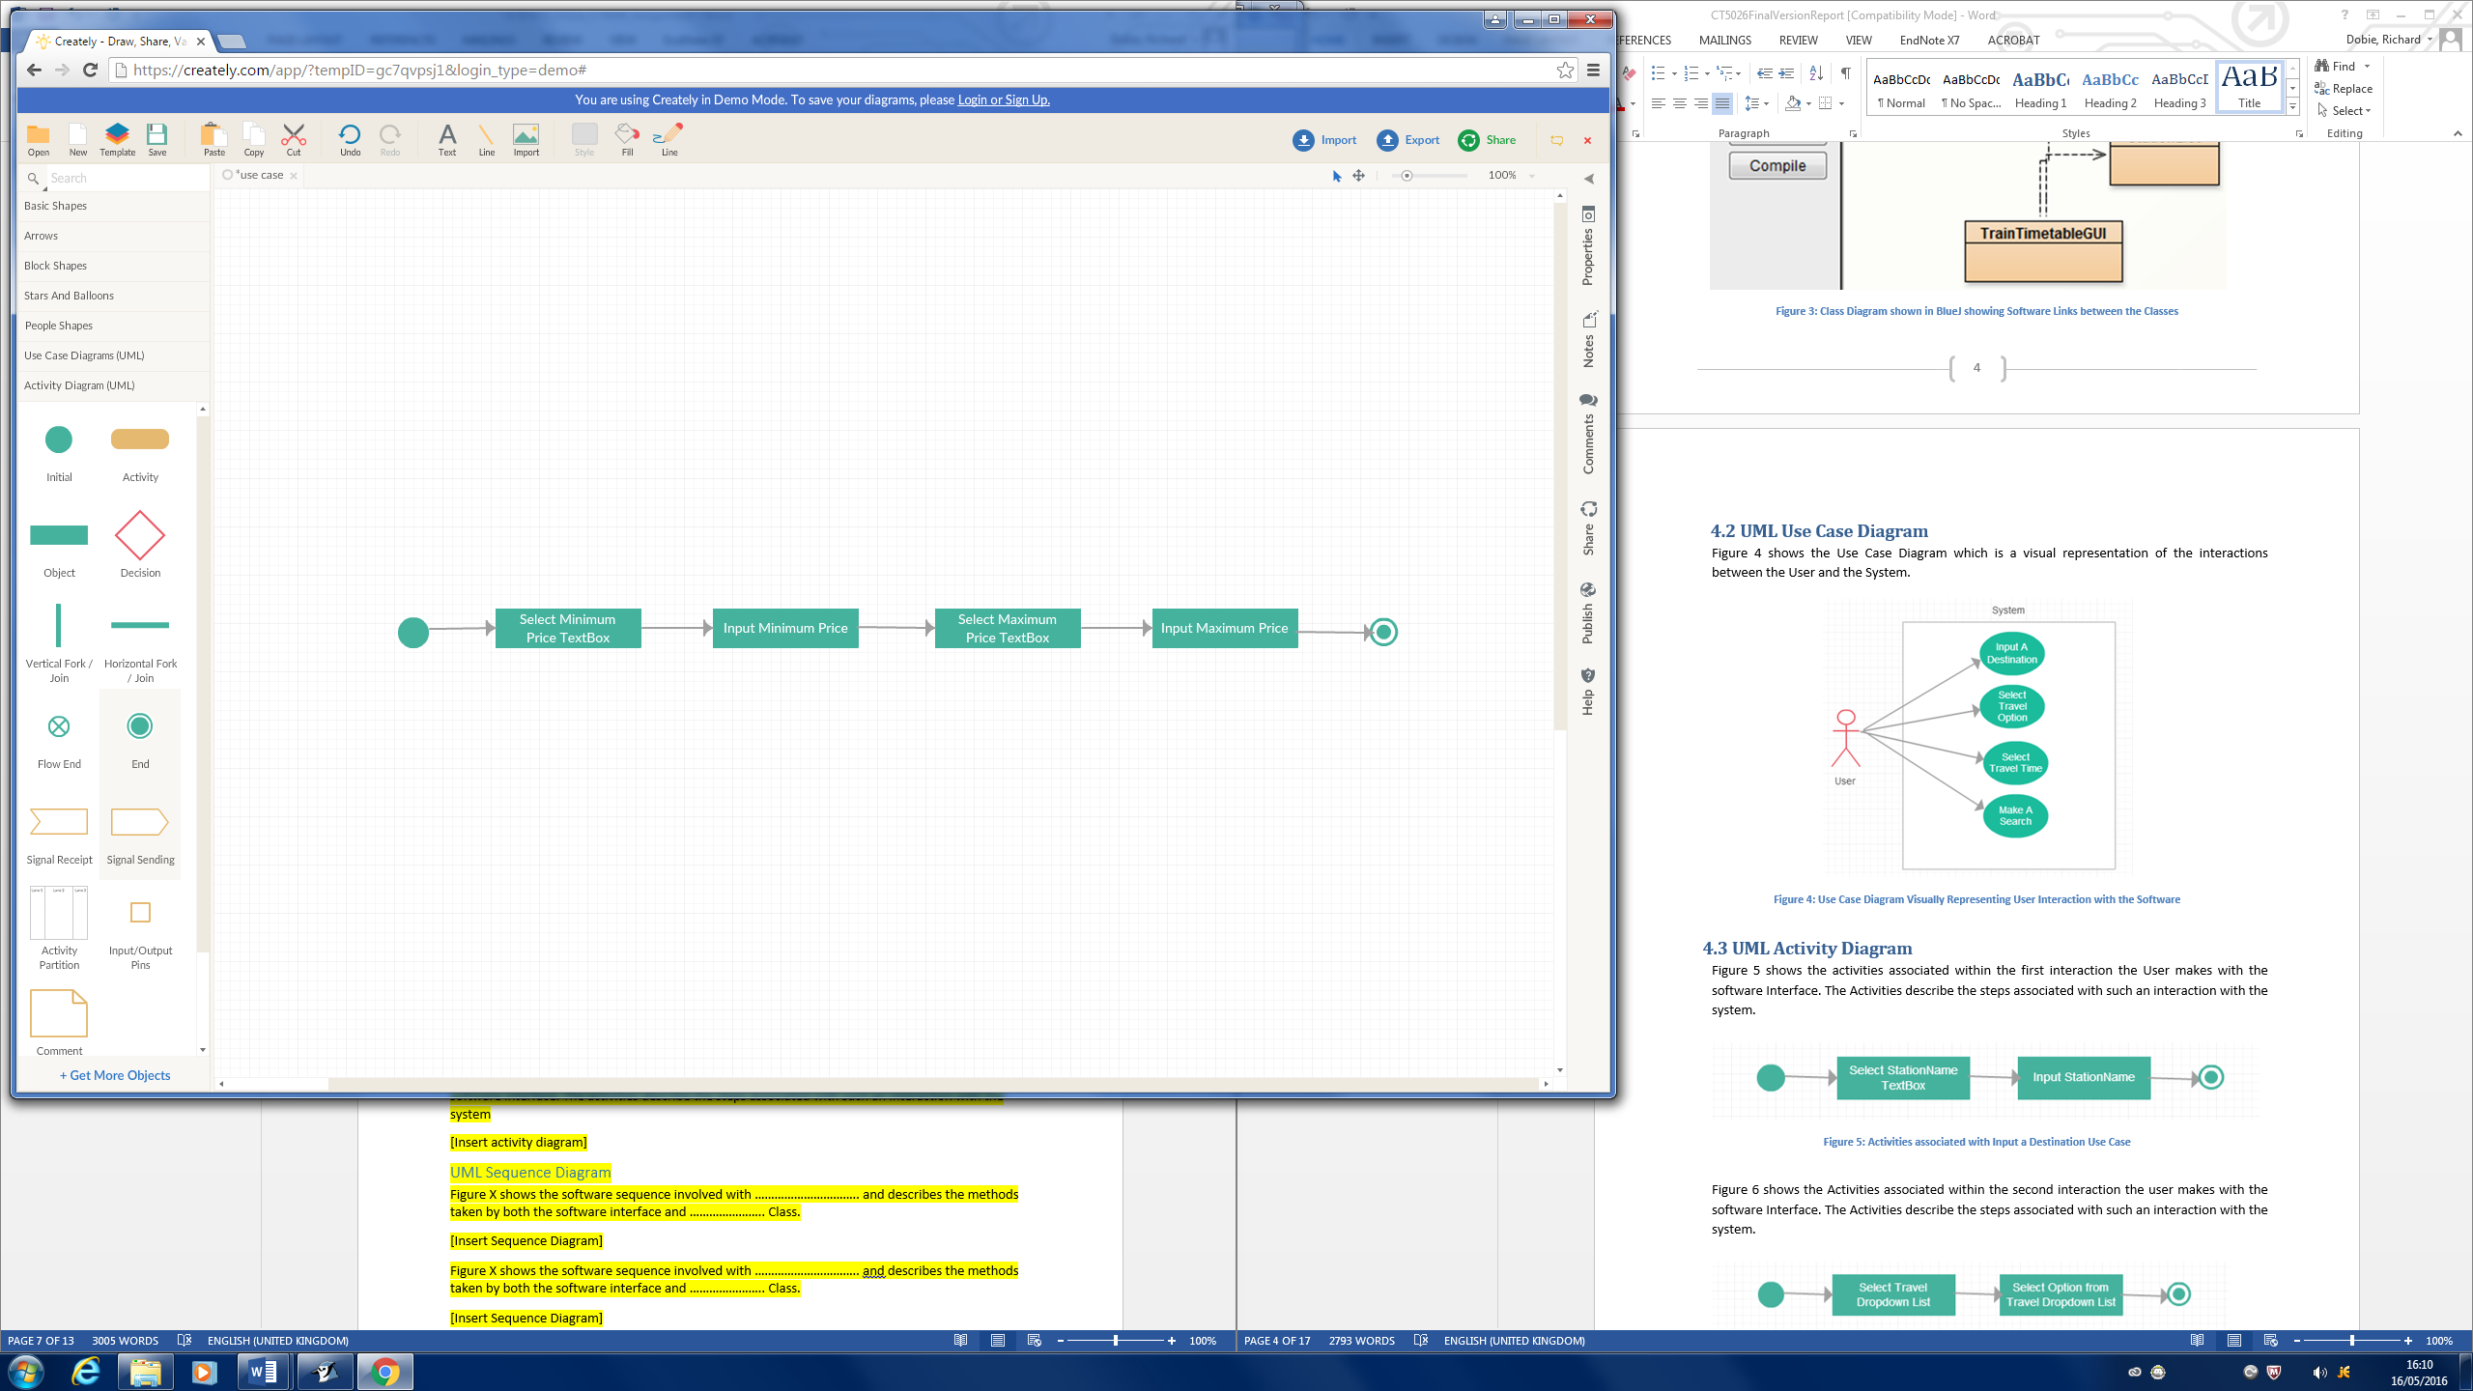

Figure 3 - Activity Diagram - Inputting Minimum and Maximum price

Figure 4 shows the activities associated within the second interaction the user makes with the software interface. The activities describe the steps associated with such an interaction with the system.

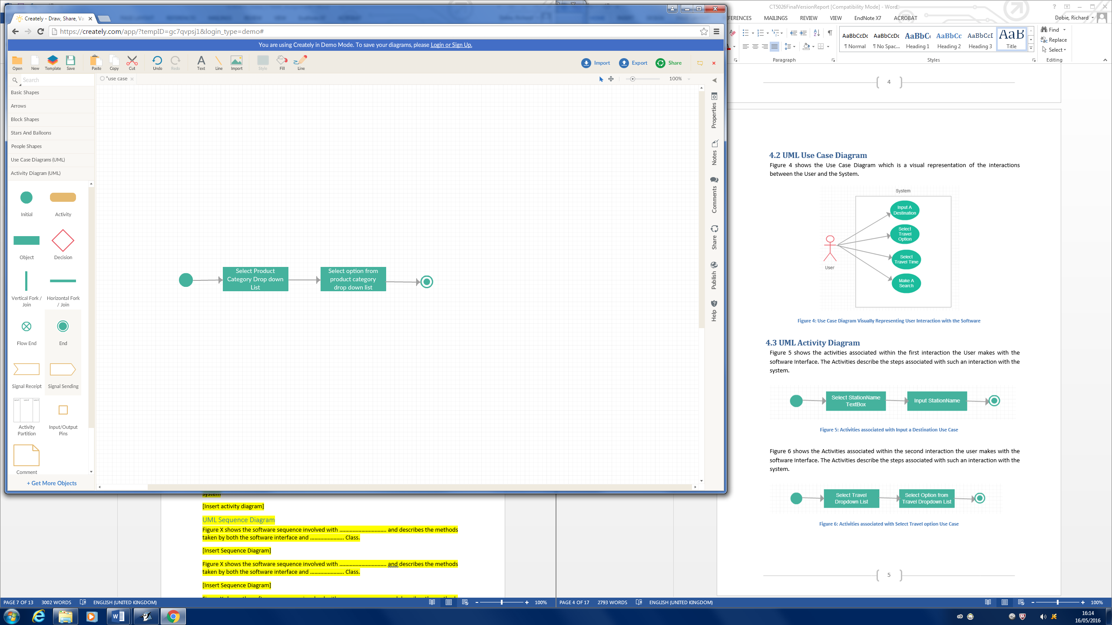

Figure 4 - Activity Diagram - Selecting Product Category

Figure 5 shows the activities associated within the third interaction the user makes with the software interface. The activities describe the steps associated with such an interaction with the system

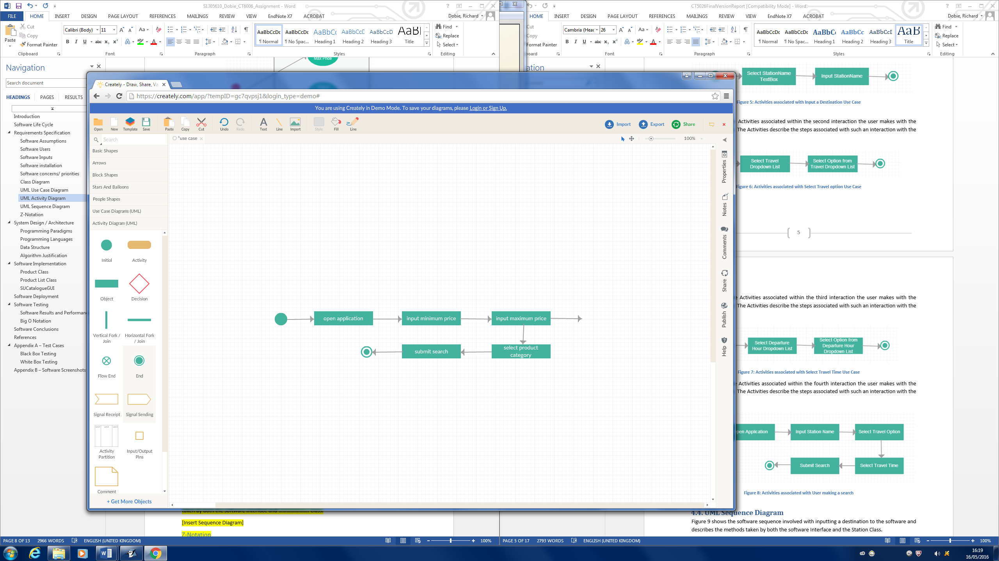

Figure 5 - Activity Diagram - User making a Search

## 3.5 UML Sequence Diagram

Figure 6 shows the software sequence involved with inputting price to the software and describes the methods taken by both the software interface and product class.

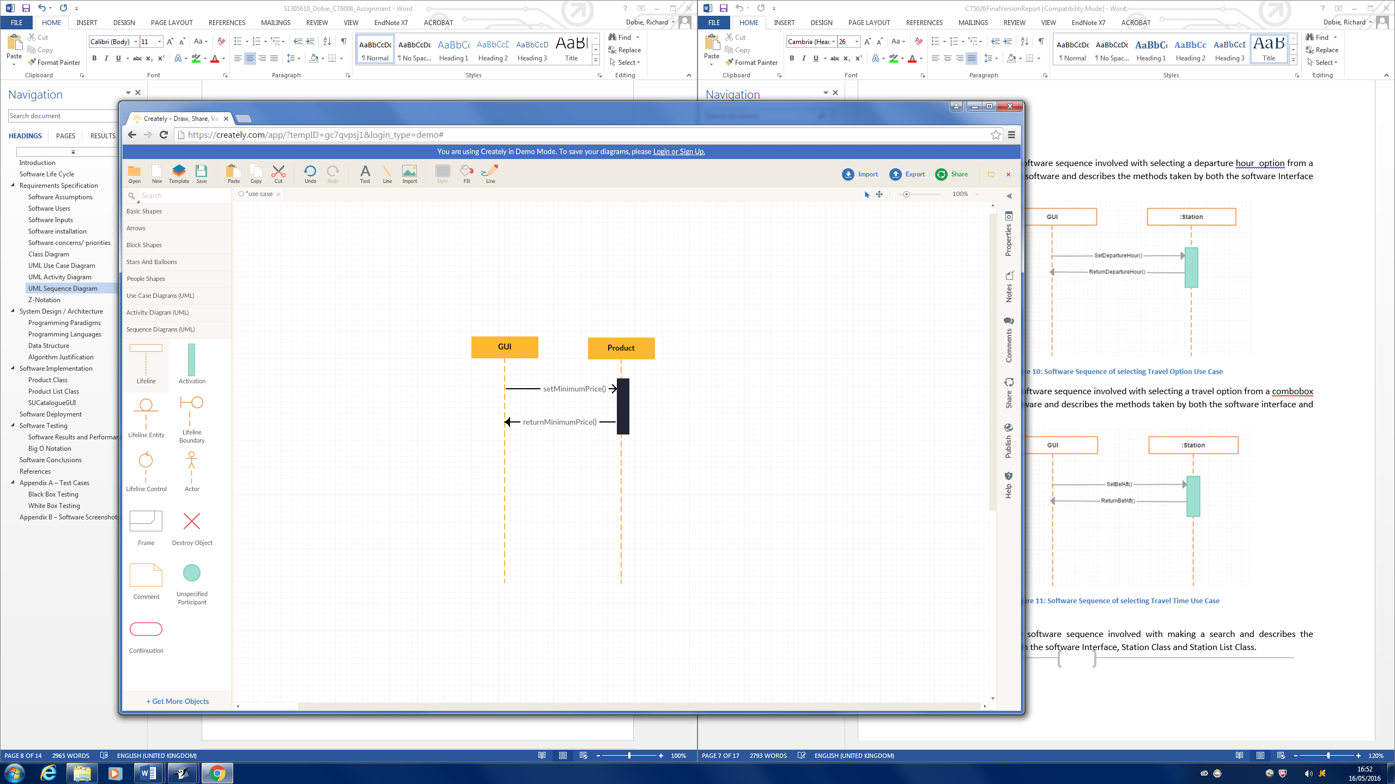

Figure 6 - Sequence Diagram - Minimum Price

Figure 7 shows the software sequence involved with inputting maximum price to the software and describes the methods taken by both the software interface and product class.

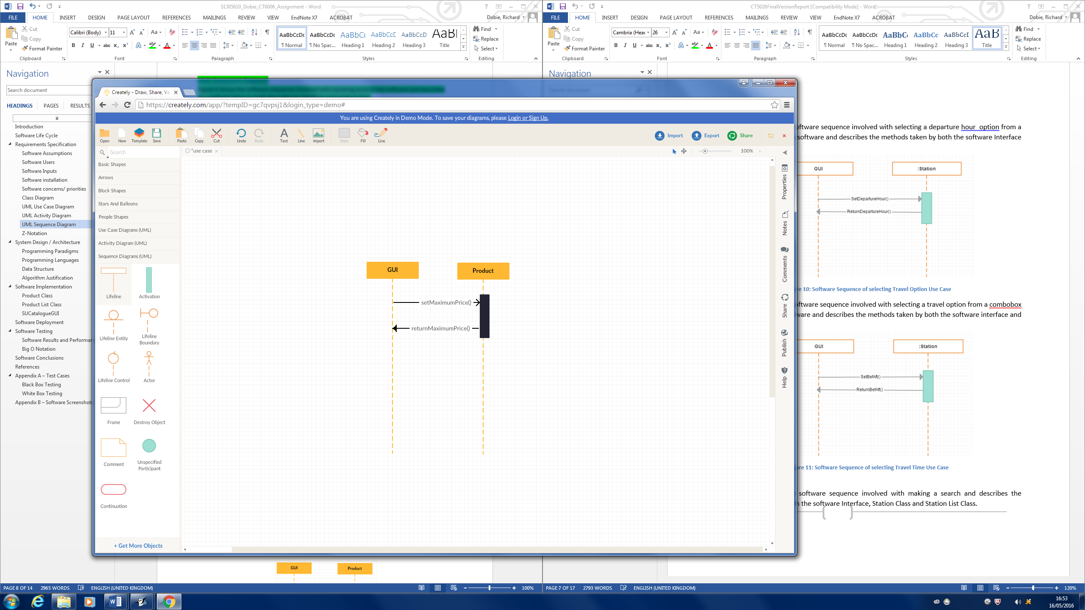

Figure 7 - Sequence Diagram - Maximum Price

Figure 8 shows the software sequence involved with selecting a product category and describes the methods taken by both the software interface and product class.

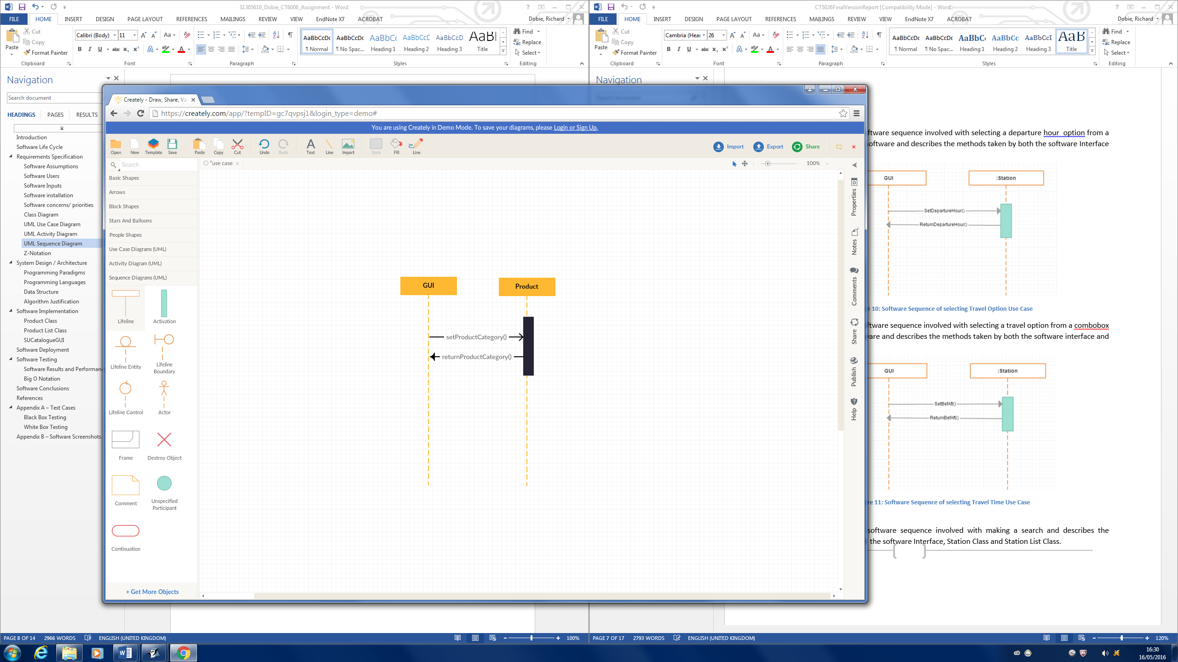

Figure 8 - Sequence Diagram - selecting product category

Figure 9 shows the software sequence involved with making a search and describes the methods taken by both the software interface, product class and product list Class.

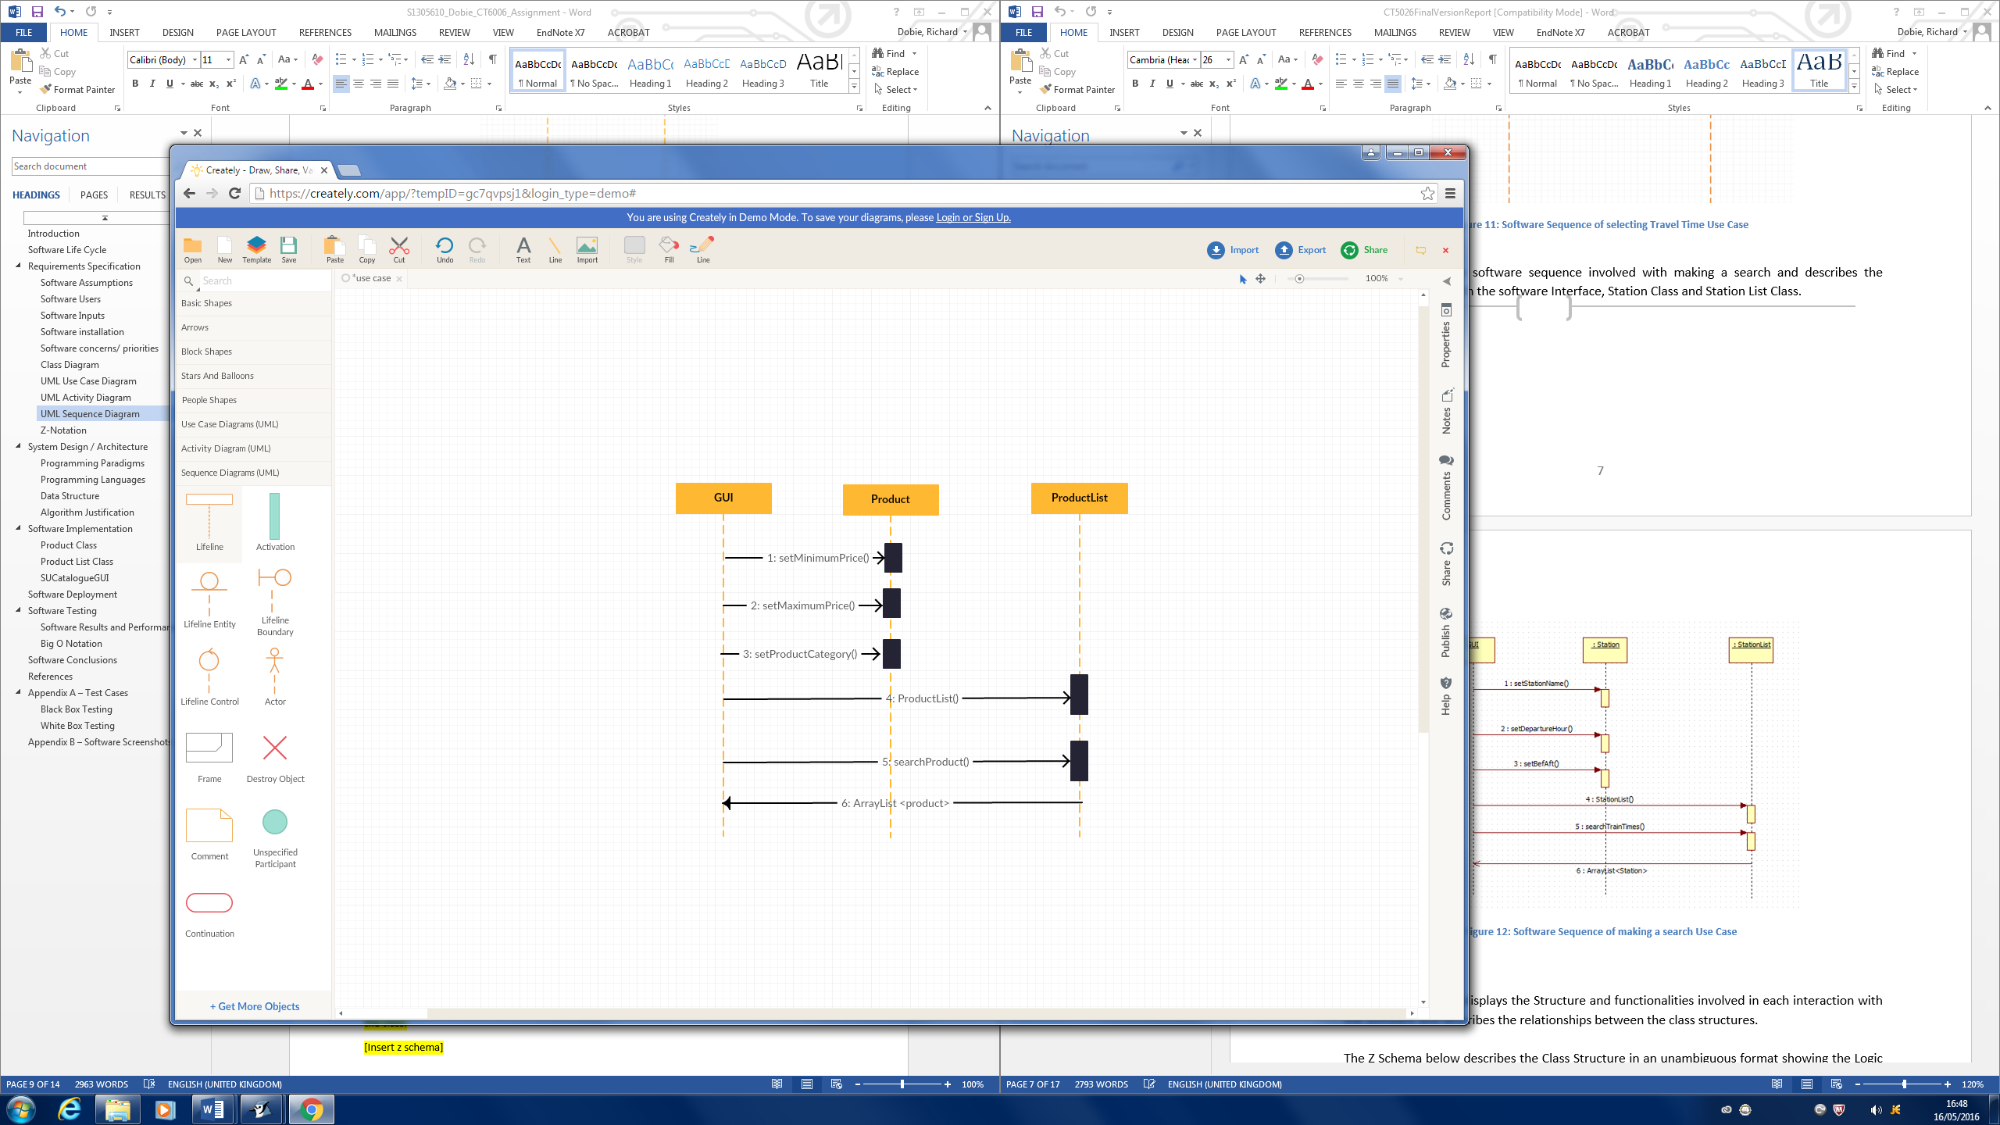

Figure 9 - Sequence Diagram - making a search

# Software Design/Architecture

The developed system was built following programming conventions and paradigms. The programming paradigms fall under two categories known as Imperative and Declarative. The programming paradigms of imperative and declarative can be subdivided into sub programming paradigms. The fig 10 shows the programming paradigm model.

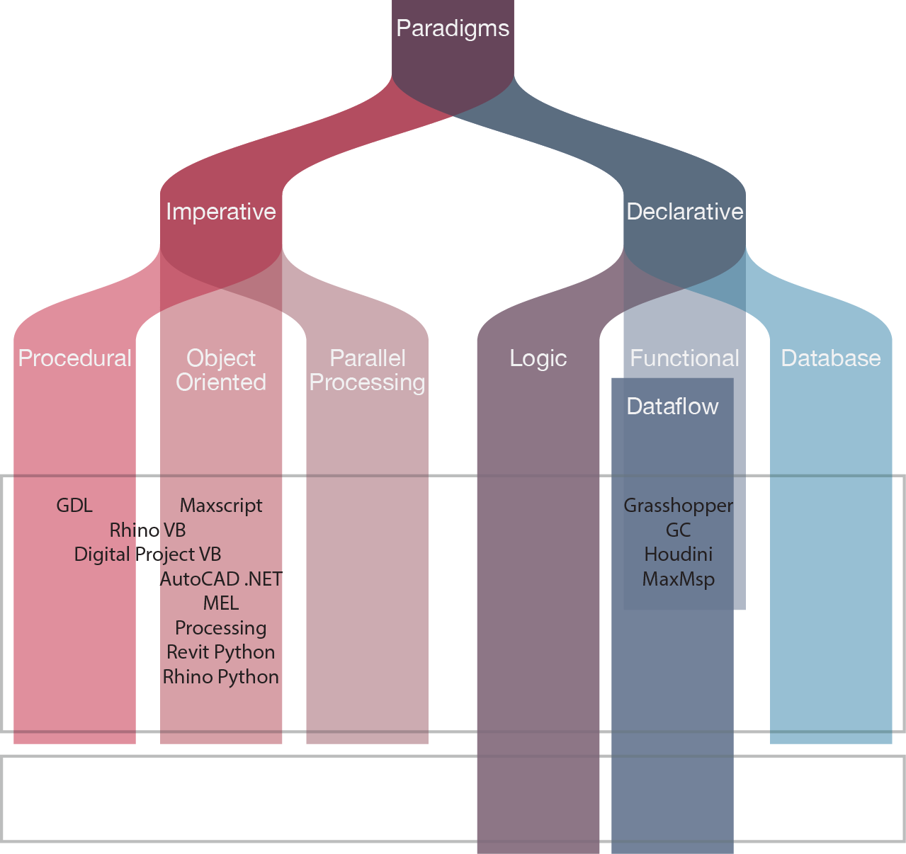

Figure 10 - Paradigms Source: (Top.idownloadnew, 2016)

The developed system according to the assignment brief had to incorporate a combination of both Imperative and declarative paradigms and associated languages. The table 3 shows the different programming paradigms the software could be developed with.

Table - Programming Paradigms Source: (Wikipedia, 2016)

|  |  |  |
| --- | --- | --- |
| Programming Paradigms | | |
| Paradigm | Description | Main Characteristics |
| Imperative | Computation as statements that directly change a program state (data fields) | Direct assignments, common data structures, global variables |
| Structured | A style of imperative programming with more logical program structure | Structograms, indentation, either no, or limited use of, goto statements, |
| Procedural | Derived from structured programming, based on the concept of modular programming or the procedure call | Local variables, sequence, selection, iteration and modularization |
| Functional | Treats computation as the evaluation of mathematical functions avoiding state and mutable data | Lambda calculus, compositionality, formula, recursion, referential transparency, no side effects |
| Event driven including time driven | Program flow is determined mainly by events, such as mouse clicks or interrupts including timer | Main loop, event handlers, asynchronous processes |
| Object-oriented | Treats data fields as objects manipulated through pre-defined methods only | Objects, methods, message passing, information hiding, data abstraction, encapsulation, polymorphism, inheritance, serialization-marshalling |
| Declarative | Defines computation logic without defining its detailed control flow | 4GLs,spreadsheets, report program generators |
| Automata-based | Treats program as a model of a finite state machine or any other formal automata | State enumeration, control variable, state changes, isomorphism, state transition table |

The analysis of the table 3 showing different possible programming paradigms that could be used for the development of the software and due to previous knowledge, it was felt that the system would be best developed following a mix of an Object-Oriented, Functional and Logical paradigm approach. The rationale for choosing to follow a mix of the above programming paradigms to design the system are discussed below.

## 4.1 Object-oriented Programming Paradigm

The object-oriented programming approach seemed most suitable for the design of the developed system, due to the object-oriented approach allowing the system to have a modular, extendable and hierarchical codebase. The object-oriented approach would be most beneficial to the design of the system as it ensures the system is thoroughly planned which enables a strong program design with minimal flaws. The object-oriented approach also has other benefits which were found to be useful for the design of the system as shown in table 4.

Table - Object-Oriented Programming Benefits Source: (Cs.drexel.edu, 2016)

|  |
| --- |
| Object-Oriented Programming Benefits |
| ***Code Reuse and Recycling***: Objects created for Object Oriented Programs can easily be reused in other programs.  ***Encapsulation (part 1)***: Once an Object is created, knowledge of its implementation is not necessary for its use. In older programs, coders needed understand the details of a piece of code before using it (in this or another program).  ***Encapsulation (part 2)***: Objects have the ability to hide certain parts of themselves from programmers. This prevents programmers from tampering with values they shouldn't. Additionally, the object controls how one interacts with it, preventing other kinds of errors. For example, a programmer (or another program) cannot set the width of a window to -400.  ***Software Maintenance:*** Programs are not disposable. Legacy code must be dealt with on a daily basis, either to be improved upon (for a new version of an exist piece of software) or made to work with newer computers and software. An Object Oriented Program is much easier to modify and maintain than a non-Object Oriented Program. So although a lot of work is spent before the program is written, less work is needed to maintain it over time. |

The object-oriented approach allows for the easy design of the software through the use of classes. The use of a class based system allows classes to exhibit attributes and model behaviour. The object-oriented approach of using classes to model attributes and behaviour allows the system to follow a functional programming approach.

## 4.2 Functional Programming Paradigm

The developed system is modelled on classes derived from following the Object-oriented programming paradigm. The use of classes allows the control of how the system has access to data which minimises the side-effects such as bugs being introduced into the system unnecessarily. The use of classes allow the concept of Objects to be used. The objects contain functions within them and associated data that can only be retrieved and modified by calling functions. The functions are inherited from objects and act as an intermediary for the retrieval and modification of data. The use of the functional and Object-Oriented paradigm ensures the system has encapsulation meaning the system variables in classes are protected from users tampering with their values which prevents system errors.

## 4.3 Logic Programming Paradigm

The developed system works on the basis of a decision making process using a knowledge base. The knowledge base is derived from the logic programming approach used in conjunction with the Object-Oriented approach. The developed system works on the basis of logic, where the program can be thought as being represented by a set of facts (statements/ relationships which are held to be true), and a set of axioms (e.g. if A is true then B is true). The axioms and clauses may have arguments (C2, 2016). The developed system is closely related to the logical programming approach, whereby the searching algorithm mimics the logic programming concept of “queries” and predicts the outcome of a student’s search criteria. The system is given a minimum and maximum price and a product category as inputted by the student. The system based on the students application “queries” whether the students given inputs match the systems product data and if the match is true then returns the matched results or if false returns no results. The Table 4 below visualises the systems logic.

Table - System Logic

|  |
| --- |
| System Logic |
| **Facts**  Product (Hoodie)  Product (T-shirt)  Product (Mug)  Product(scarf)  Product(shorts)  Product(Hat)  ProductPrice (Hoodie, £19.99)  ProductPrice(T-shirt, £15.99)  ProductPrice(Mug, £5.99)  ProductPrice(Scarf, £10.99)  ProductPrice(Shorts, £29.99)  ProductPrice(Hat, £9.99)  **Rules**  If (MinimumPrice +, MaximumPrice) = Product (ProductPrice) => return results  If (MinimumPrice +, MaximumPrice) ≠ Product (ProductPrice) => no results returned  **Queries**  Product (MinPrice - £0 + MaxPrice - £10, ProductCategory - Hoodie) => no results returned  Product (MinPrice - £0 + MaxPrice - £10, ProductCategory - Mug) => all mug results returned |

# Software Implementation

The software implementation and development of the code is analysed and described below.

## 5.1 Java

The developed system has been built using a combination of programming paradigms. The main programming paradigm used is the imperative paradigm. The system is developed using Java which is an imperative programming language. The rational for using Java as the main programming language for the developed system is shown below in Table 6.

Table - Rationale for Java Source: (IBM, 2016)

|  |
| --- |
| Rationale for choosing Java programming Language |
| Java is easy to learn – due to the timescale to develop the system it seemed sensible to use Java as the main programming language as it is a programming language that I have mostly used in the past to develop small pieces of software. |
| Java was designed to be easy to use and is therefore easy to write, compile, debug and learn than any other programming language |
| Java is Object-Oriented – the decision to choose Java allows the system to be developed using OOP principles which allows the system to be modular and the code to be reusable |
| Java is platform independent – the developed system needs to be able to be installed on any platform therefore using java allows the system to be run on many different platforms |

The system due to the use of Java as the main programming language allows the code to be developed to Object-Oriented principles. The use of Object-Oriented programming allows the system classes to be constructed following the functional programming paradigm. The functional paradigm and Object-Oriented programming allows the system code to be easily maintained and ensures the software is robust.

The system also is closely linked to the Logical programming paradigm which allows the system to predict the outcome of the student’s product search. The use of Logical programming concepts ensures the system will produce the correct outcome no matter how many applications the system deals with. The use of logical programming concepts ensures the program is robust enough to handle the amount of users and searches the system must deal with and it is important that the system is robust as any errors in the systems logic would be fatal to the university administration process.

## 5.2 Scala

The system was intended to be built using Scala, as Scala is a declarative programming language. The intention to use Scala within the codebase for the system was due to the fact that Scala is a “scalable language”. The Scala programming language is complimentary to the use of Java programming language as Scala supports object-oriented and functional programming paradigms (tutorialspoint, 2016). The system setup is based on the object-oriented concept that every value is an object and every operation is a method call. The Scala language supports functional programming through the use of first class functions, a library with efficient immutable data structures and a general preference of immutability over mutation. The Scala language would have been beneficial to use for future proofing the software due to its functional nature that would make it easier to write safe and performant multi-threaded code.

The developed system was unable to incorporate the use of Scala due to having no previous knowledge of Scala and only having a small timescale to implement the system in. The system programmed in Java has a lot of similarities in regards to the Scala language as both complement each other and work well together. The Fig 11 below shows that I am able to write Scala code although I was unable to implement it within the system codebase.

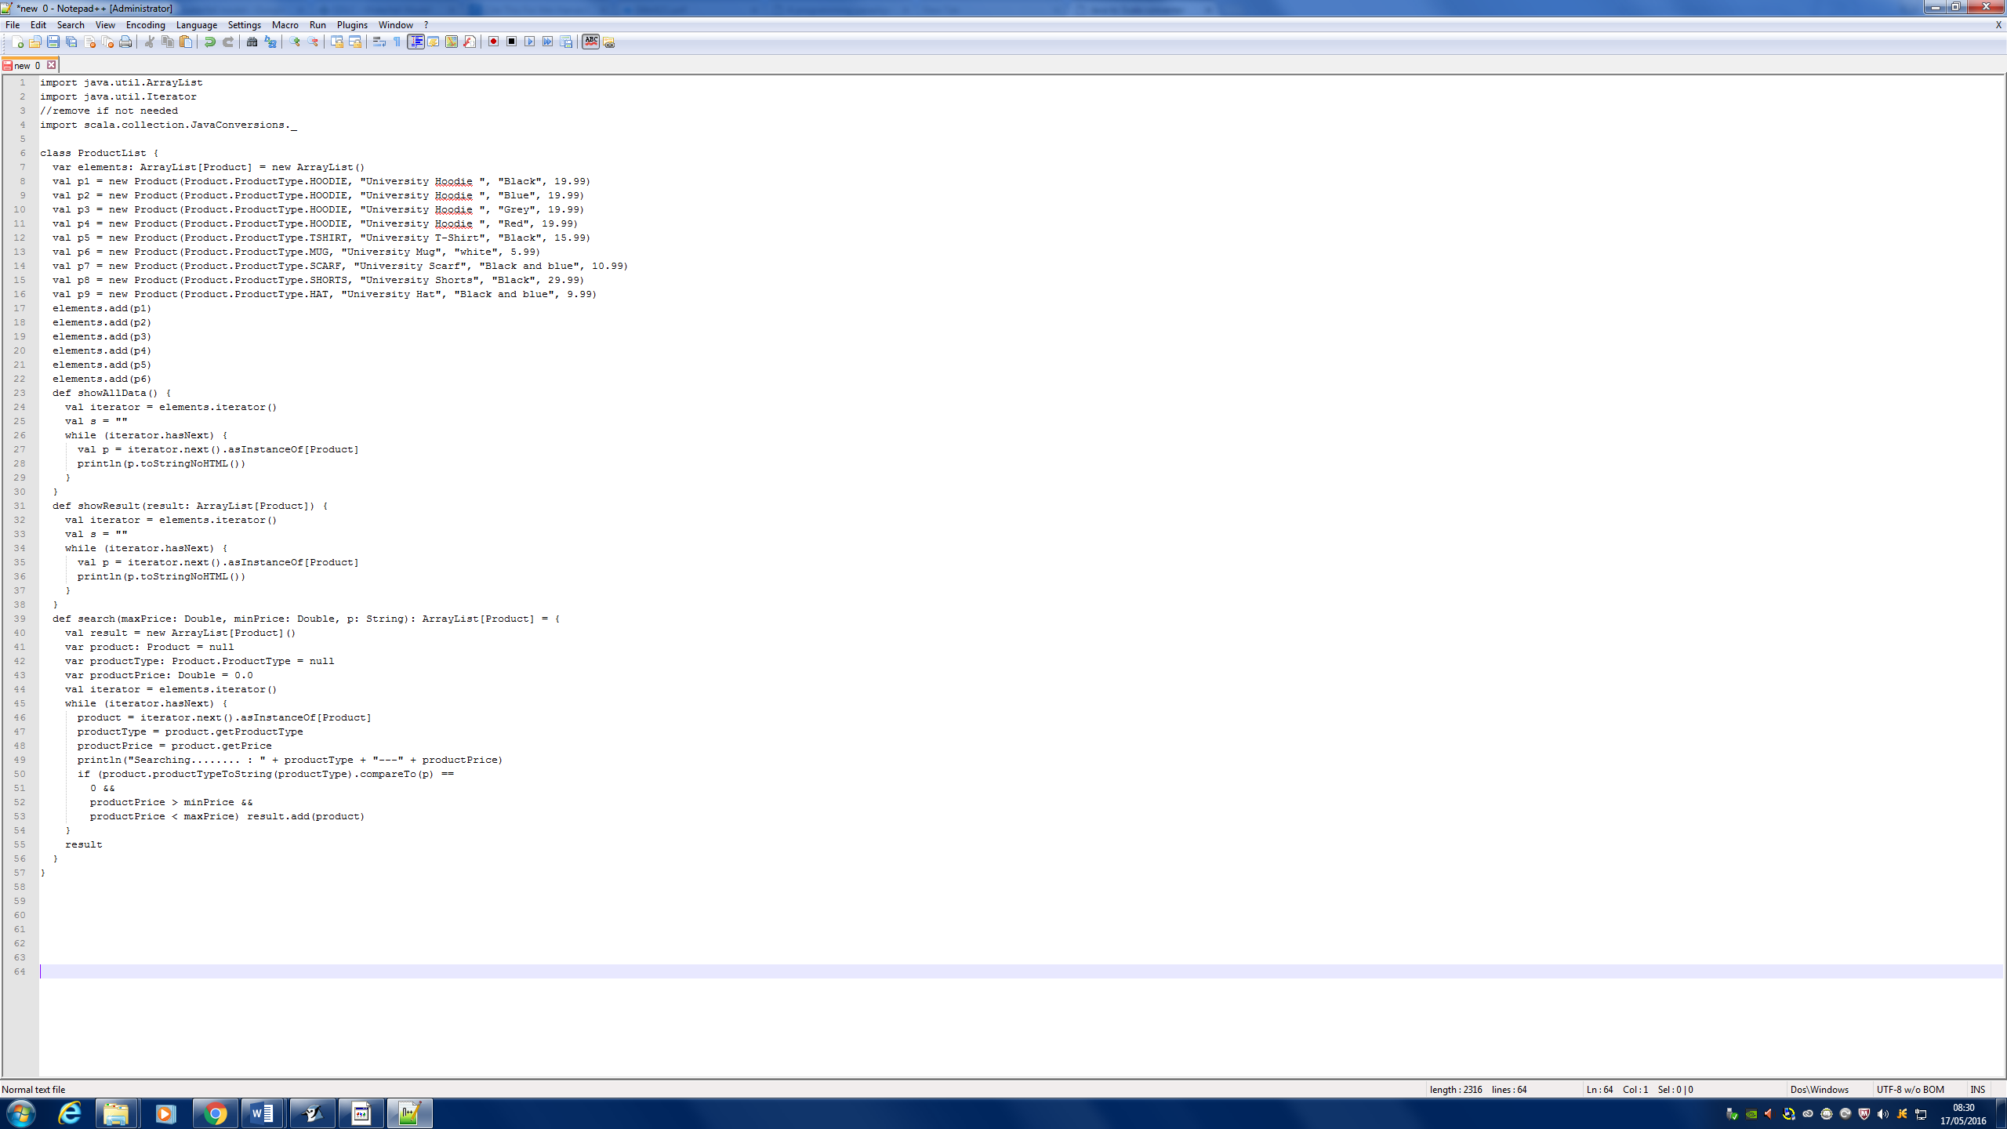

Figure 11- Scala code for Product List Class

## 5.3 Prolog

The developed system was designed to have logic built into it via the ability for the system to return outputs based on the data the user enters to the system. The system currently works with logic due to the nature of the searching function. The searching function works by matching the students inputted data to the inbuilt data within the system to see if there is a match or not and returns the search results to the user. The system although having logic like concepts based on logical programming languages like prolog, it was not possible to incorporate prolog into the system codebase. The system was unable to use prolog in it’s codebase as prolog works by querying data held in a storage medium such as a database. The system does not store or retrieve data from a database so it was felt using prolog would not be suitable. Although the system is not programmed using prolog to query data and provide logic to the system I am still aware how to write prolog facts, rules and queries as shown in Table 7 below.

Table - System Logic

|  |
| --- |
| System Logic |
| **Facts**  Product (Hoodie)  Product (T-shirt)  Product (Mug)  Product(scarf)  Product(shorts)  Product(Hat)  ProductPrice (Hoodie, £19.99)  ProductPrice(T-shirt, £15.99)  ProductPrice(Mug, £5.99)  ProductPrice(Scarf, £10.99)  ProductPrice(Shorts, £29.99)  ProductPrice(Hat, £9.99)  **Rules**  If (MinimumPrice +, MaximumPrice) = Product (ProductPrice) => return results  If (MinimumPrice +, MaximumPrice) ≠ Product (ProductPrice) => no results returned  **Queries**  Product (MinPrice - £0 + MaxPrice - £10, ProductCategory - Hoodie) => no results returned  Product (MinPrice - £0 + MaxPrice - £10, ProductCategory - Mug) => all mug results returned |

## 5.4 Code Analysis

The developed system was designed following the Object-Oriented Programming approach. The Object-Oriented approach works on the concept of creating classes which store variables and methods to accessing those variables. The system therefore was setup using classes that were selected based on using noun analysis of user requirements. The use of noun analysis helped to identify how many classes the system needed. The following table below shows the noun analysis based on the user requirements.

Table - User Requirements

|  |
| --- |
| System Requirements |
| The system must have a User Interface |
| The system must allow SU staff to add products to the system |
| The system must be able to store a list of product details |

The noun analysis on the above table highlighted the following key words: User Interface, Product, and Product List. The noun analysis identified three main keywords which suggested that three classes were needed for the system. The rationale for why three classes were needed for the system is shown in the table below.

Table - Rationale for using 3 classes

|  |
| --- |
| Rationale for using 3 classes |
| **User Interface**  the system needs a way for the end users to interact with the system so therefore it was decided a User Interface class was needed to contain all the information regarding the User Interface  **Product**  The system is used to sell university SU merchandise so therefore the system needs a way for products to be added to the system. The system therefore needs a Product class which will allow the system to handle information regarding product details  **Product List**  The system must be able to store the product details that will be entered to the system in a list which can allow end users to search and find results that match their queries. |

The system classes have been chosen following the noun analysis on user requirements. The system classes were then developed following the Object-Oriented programming approach. The structure of each of the three classes is discussed in the following section below.

## 5.5 Code Structure

### 5.5.1 Product Class

The product class was decided to be needed by the system as the system requires the university SU staff to be able to add products to the system. The product class was structured following an Object-Oriented approach where the class declares variables for product details and methods for how the product variables data are accessed.

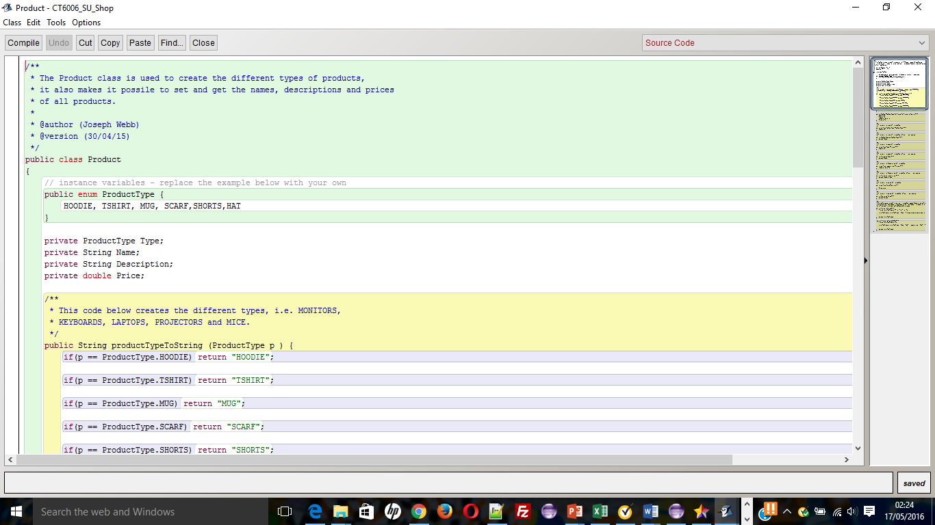

Figure 12 - Code Snippet - Enum

The figure 12 above shows that a decision was made to use an Enum to define the product categories the system will use to allow end users to be able to narrow down their search results to a specific product category. The way to define the product categories had two possibilities which were either use constants or Enum. The following Figures 13 and 14 below show how the product categories could be coded using constants and enum.

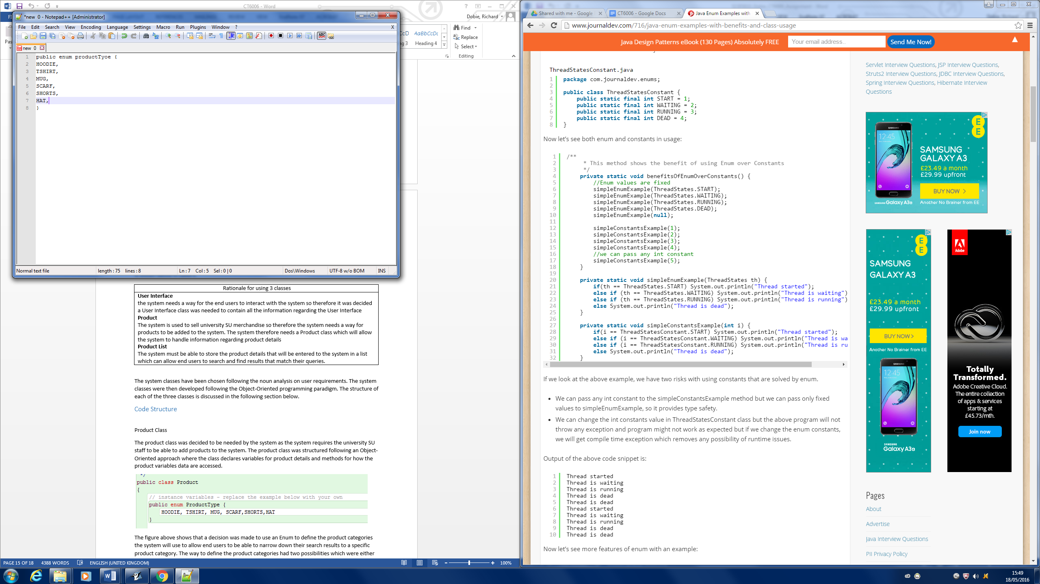

Figure 13 - Code Snippet Enum

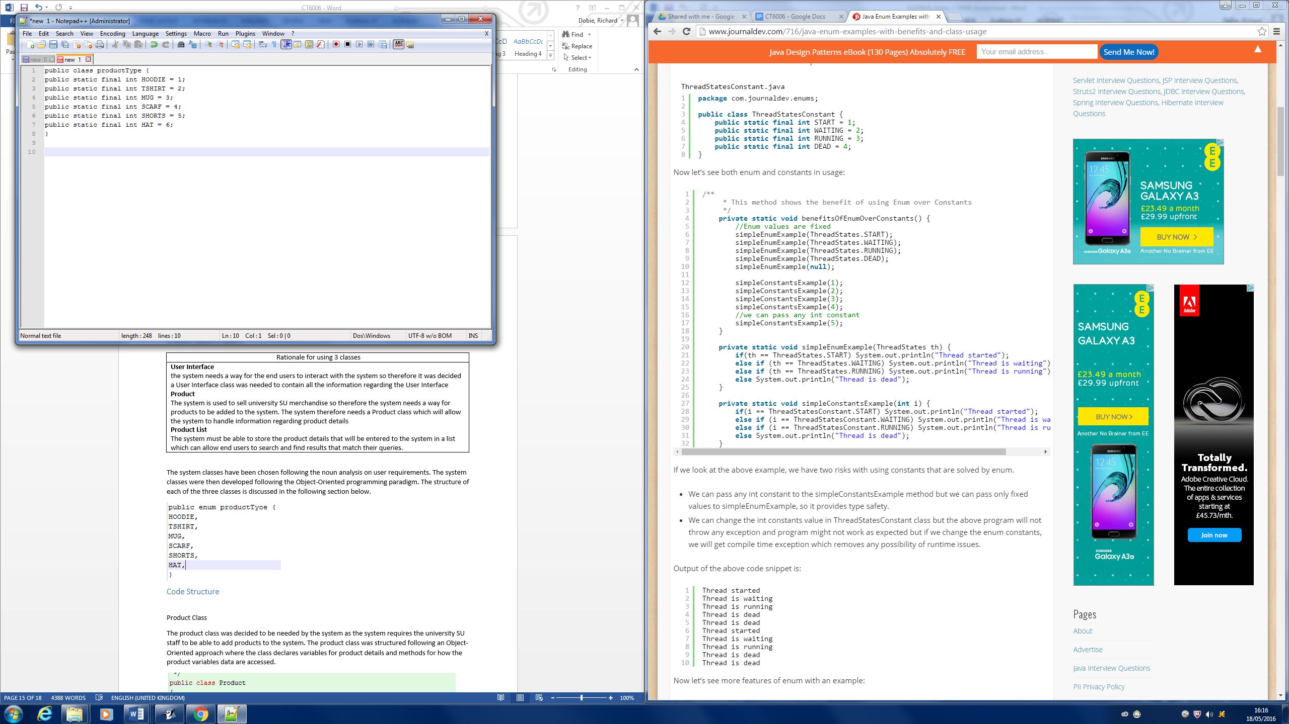

Figure 14 - Code Snippet Constant

The above code examples show the difference between using enum and constant. The above code highlights two risks associated with writing the code using constants. The two risks are the following:

Table - risks associated with using constant

|  |
| --- |
| Risks associated with using Constant |
| * Using constant any int can be assigned whereas using enum only fixed values are assigned which provides type safety * The int values of constant can be changed without throwing any exceptions and program might not work as expected but if the enum is changed the program throws a compile time exception error which removes any possibility of runtime issues. |



Figure 15 - Code Snippet showing Variables

The figure 15 above shows that a decision was made to declare variable names for product details. The figure above shows that the variable names are constructed as private variables. The way to declare the variables for the class has three possibilities as shown below:

Table - Methods for declaring Variables

|  |
| --- |
| Methods for Declaring Variables |
| * Public Variables – variables that are visible to all classes * Private Variables – variables that are visible only to the class to which they belong * Protected variables – variables that are visible only to the class to which they belong, and any subclasses. |

Source: (Javacoffeebreak.com, 2016)

The decision to make the variables private was due to looking at the risks of public and private variables as shown below:

Table - risks of methods for declaring variables

|  |
| --- |
| Risks of Methods for declaring Variables |
| * Public variables – having public variables would mean that any object in the system could change the data to an invalid type which would cause the system to fall over even if constructors were used to prevent unsuitable data types for the variables. * Private Variables – having private variables helps protect the data from invalid data types whilst still offering the objects access to the data via the use of get and set methods. |

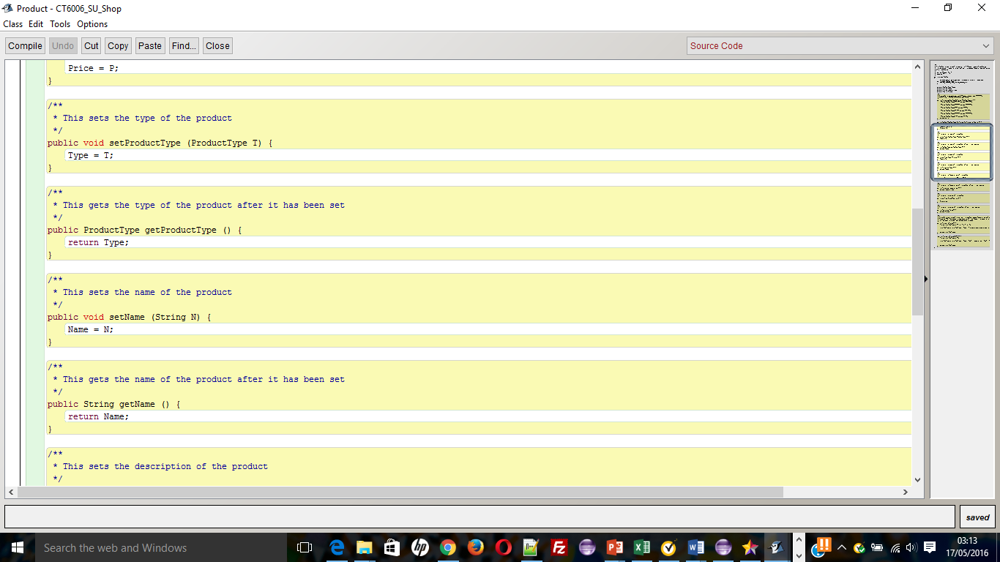

Figure 16 - Code Snippet Get and Set Methods

The figure 16 above show that a decision was made to use get and set methods. The decision to use get and set methods was due to the decision to setup the variables as private variables. The get and set methods according to (correctly, 2016) serve to set and get values from class variables that are defined as private. The benefit to using get and set methods with private variables are shown in the table below. The table highlights benefits such as data validation, ease of code debugging, usability of code which for this system ensures the systems data is protected and reduces risk of system running incorrectly and returning incorrect results.

Table - Benefits of get and set methods

|  |
| --- |
| Benefits of Get and Set methods |
| 1) Getter and setter method gives you **centralized control** on how a particular field is initialized and provided to client which makes validation and debugging much easier. You can simply put a breakpoints or print statement to see which thread are accessing and what values are going out.  On validation front, you can easily avoid an incorrect value for a particular field, i.e. if field is non nullable than you can throw NullPointerException or IllegalArgumentException. with public field your client code will break when it start using that field without knowing which part of your code is setting incorrect or null value.  2) By making fields private and providing getter and setter and following java bean naming convention you make your class usable with many open source library and framework e.g. display tag. which uses combination of reflection and Java bean naming convention to dynamically load and access fields.  3) with getter and setter you give an opportunity to Subclass to override these method and return what makes more sense in context of sub class. |

Source: (Javarevisited.blogspot.co.uk, 2016)

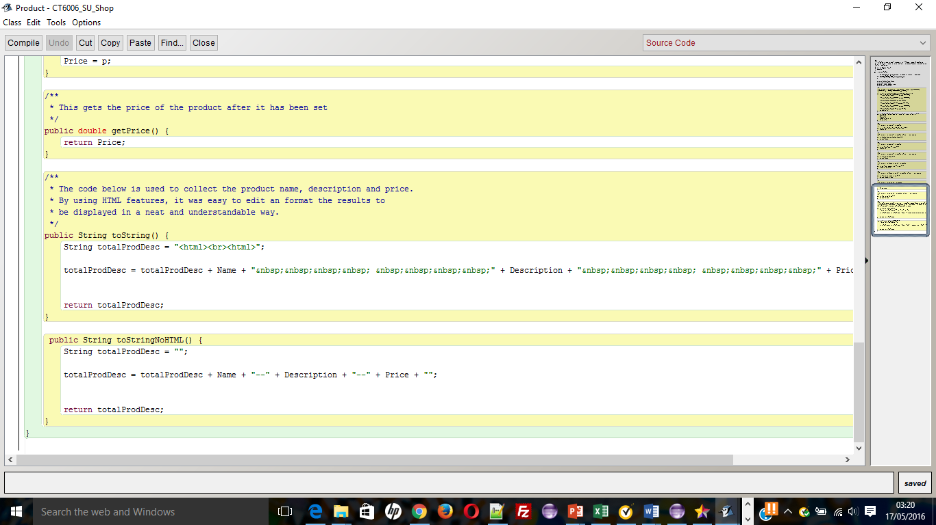

Figure 17- Code Snippet - formatting of results

The figure 17 above shows that a decision was made to use the toString () method in order to print the search results to the user via the graphical user interface. The benefit to using the tostring () method in the system is to allow clear and concise information about the product to be formatted in a readable way to the end user (Javarevisited.blogspot.co.uk, 2016)

### 5.5.2 Product List Class

The product List class was decided to be needed by the system as the system requires the university SU staff to be able to add products to the system and store those products in a list in order for a student to be able to query that list and the system to return results. The product List class was structured following an Object-Oriented approach where the class declares variables for product details and methods for how the product variables data are accessed.

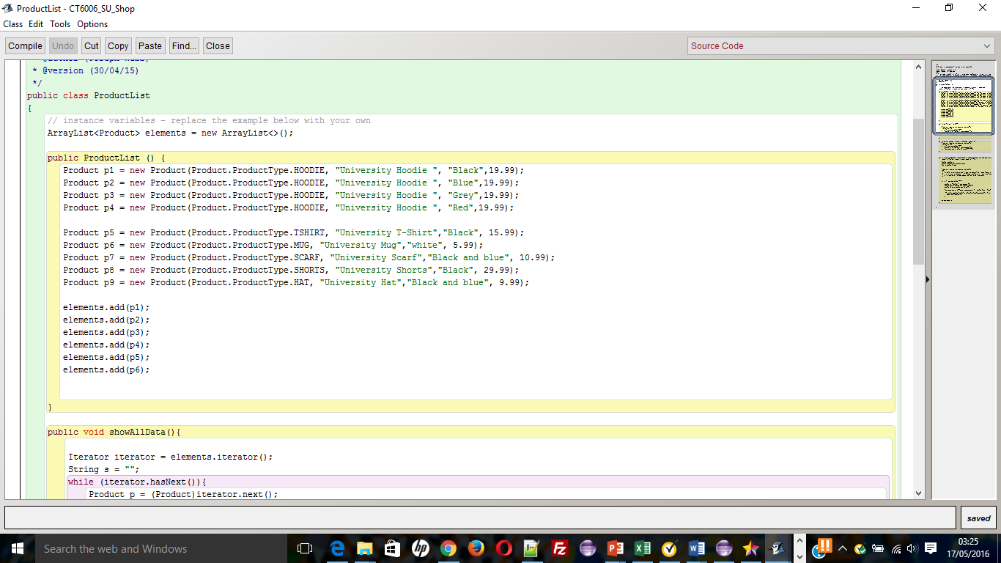

Figure 18 - Code Snippet - ArrayList

The figure 18 above shows that a decision was made to setup an ArrayList to store product details. The decision to use ArrayList over alternative options are shown in the Table below.

Table - ArrayList Vs Linked List Vs Vector Comparison Source: (dzone, 2016)

|  |
| --- |
| Comparison of Array List Vs Linked Lists Vs Vector |
| **ArrayList**  Implemented as a resizable array  Size is increased dynamically as more elements are added  Elements can be accessed directly using get and set methods since array list is essentially an array  Array list better choice if program is thread safe  Require space as elements are added  Grows 50% of its size each time  **Linked List**  Implemented as a double linked list  Performance on add and remove is better than ArrayList  Worse on get and set methods than ArrayList  Implements queue interface which adds more methods in comparison to ArrayList and vector  **Vector**  Similar to ArrayList but is synchronised  Require space as elements are added  Doubles it’s array size |

The use of the ArrayList for the storing of product information was seen to be the most suitable for this system due to the fact that the ArrayList works well with get and set methods as discussed above and also benefits by the ability for the elements in the array to be directly accessed directly in comparison to linked list which reduces the cost of the algorithm. The other benefit of using an ArrayList is that the size of the ArrayList can be increased dynamically as more data is needed (Patil, 2016).

.

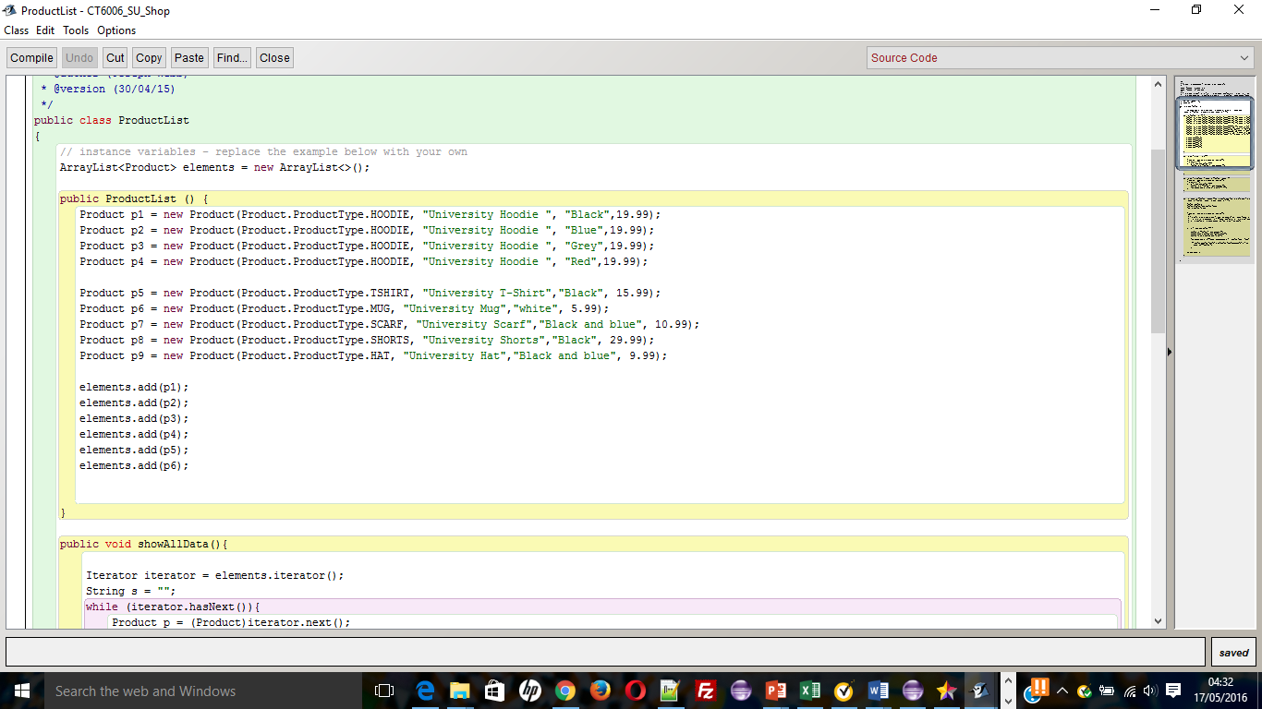

Figure 19 - Code Snippet - Product data

The figure 19 above shows the method used to create the product data used in the system. The data is created within the system product list class rather than alternatives such as using a text file or storing data on a database. The decision to create the data within the application over using a text file or storing on a database was due to keeping the complexity of the system to a minimum. The use of a text file or database would have made the searching algorithm more complex as the system will have needed to access the data externally to the system which would affect time performance of the system.

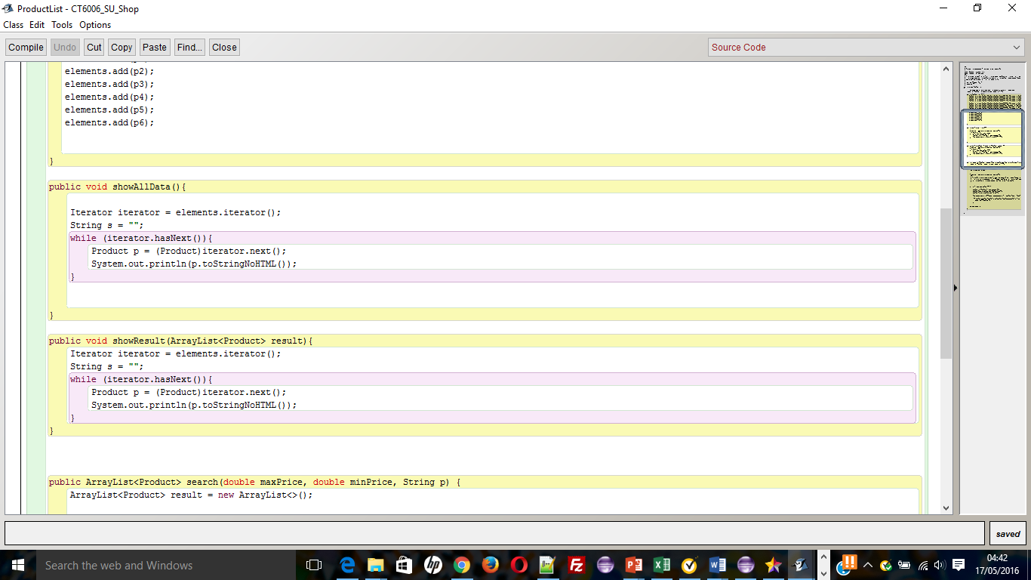

Figure 20 - Code Snippet - Iterator

The figure 20 above shows the method used to navigate the ArrayList and print information to the graphical user interface. The decision to use an iterator was based on analysing the alternative methods. The use of a for loop is in many cases quicker than an iterator, however as the time difference is a matter of milliseconds this would be unlikely to inconvenience the end user. The decision to use an iterator is due to it being an efficient way to loop through a list or collection such as is used in the system which is beneficial for the future as the system deals with larger amounts of data in the future (Mkyong.com, 2009).

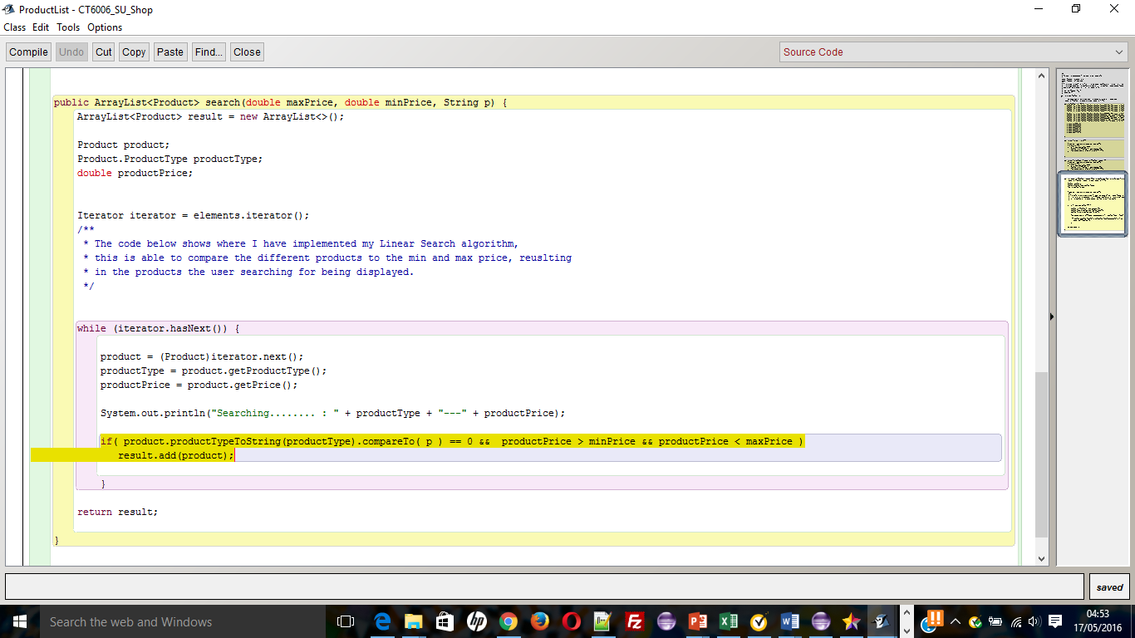

Figure 21 - Code Snippet - Search Algorithm

The figure 21 above shows the searching method used to search the array list of product types data and logically evaluates based on the users min and max price and product category whether the array list items match the users query and if so either results are printed or no results are printed. The searching algorithm uses a linear search to carry out the search on the array list. The rationale for choosing the linear search over the alternative of binary search are shown in the table below.

Table - Linear Search Vs Binary Search

|  |
| --- |
| Linear Search Vs Binary Search |
| The consideration of the Binary Search Algorithm was due to the fact that the Algorithm uses a technique called divide and conquer which involves the algorithm making less comparisons against the data which would make the algorithm efficient at returning results. The disadvantage of the binary search is that it is more suited to only finding a single result.  The consideration and use of the Linear Search Algorithm was due to the fact that the linear search algorithm can be just as efficient as the binary search algorithm with the benefit that the linear search algorithm is more suited to searching and returning multiple results |

Source: (Studytonight.com, 2016)

The table 15 discusses how linear search is more suited to searching and returning multiple results. The system will return multiple search results dependent on the users search criteria so therefore it was better to use a linear search algorithm.

### 5.5.3 SUCatalogueGUI class

The SUCatalogueGUI class was decided to be needed as the system required a user interface to allow users to interact with the system. The choices of interfaces for the system were either graphical user interface (GUI) or command line. The advantages and disadvantages of using a GUI interface or command line interface are shown in the table below.

Table - GUI Vs Command Line

|  |
| --- |
| GUI Vs Command Line |
| * **Command-line interfaces are better for more complex actions**, which you want to repeat (and possibly automate) and when you need to operate with many objects. They are closer to the advantages of UNIX style command line shell operations which utilize advantage of human capacity for expressing complex thoughts in the artificial subject oriented language. * **GUIs are better for using direct manipulation**, and for using the selected object to narrow down the range of possible actions. GUIs take more advantage of our ability to quickly perceive and interact with images. |

Source: (Softpanorama.org, 2016)

The graphical user interface was chosen over the text based interface as the system involved user interaction which was easier to achieve using a graphical user interface than a text based interface. The use of a graphical interface allows greater usability as the end user would be more familiar with using a graphical interface than text based.

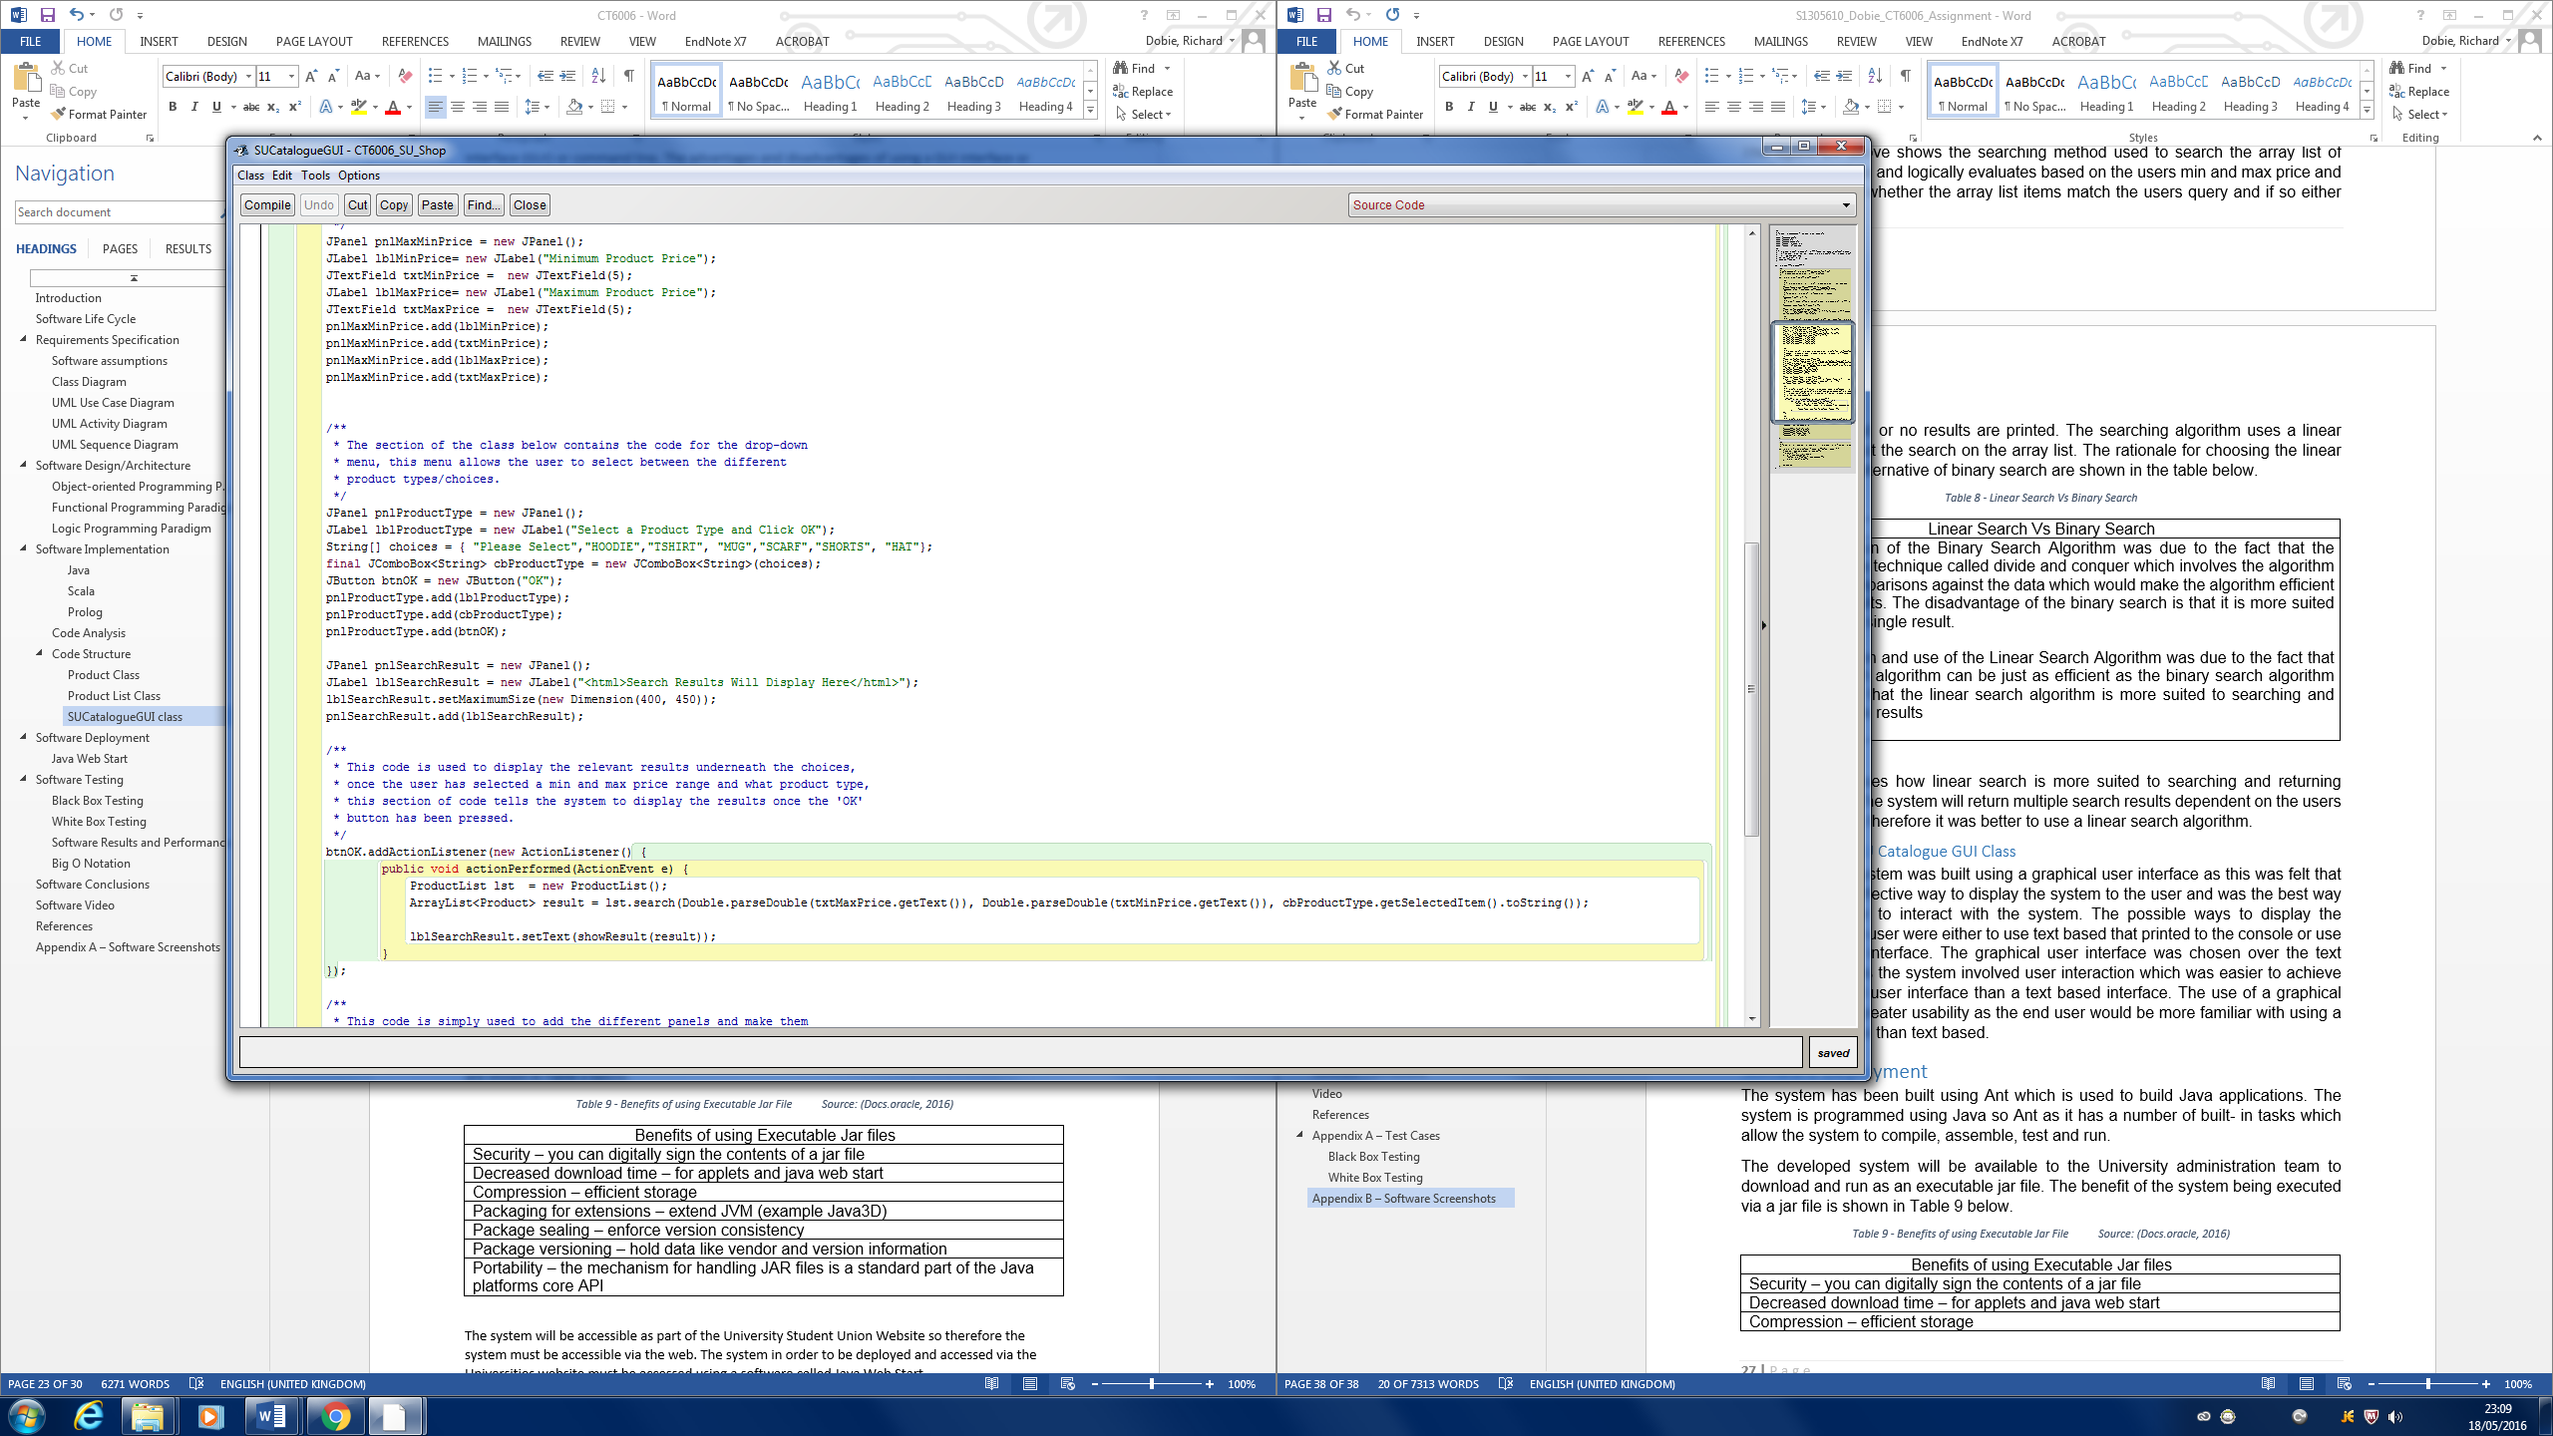

Figure 22 - Code Snippet format of results

The figure 22 above shows an action listener was used to define what should be done when the user clicks the search button on the graphical user interface [ref]. The easiest type of event listener is an action listener. The action listener is used in the GUI class as it is important that the search of data does not happen until the user has entered both minimum price, maximum price and has selected a product category (Docs.oracle.com, 2016). The event handler works by waiting till all data is entered and the user has clicked the search button. The search button then fires the action event which invokes the searching algorithm and tells the algorithm which product details to look at from the ArrayList (Docs.oracle.com, 2016).

# Software Deployment

The system has been developed using an Integrated Development Environment (IDE). The system will not be run by the University SU Staff or Students via an IDE so therefore the system had to be built and packaged for deployment. The system is programmed in a Java Development Environment so therefore the system was built using Ant Build which is the build client for Java programs. The ant build will package the system into an executable jar file. The benefit of using an executable jar file are shown in Table 17 below.

Table - Benefits of using Executable Jar File Source: (Docs.oracle, 2016)

|  |
| --- |
| Benefits of using Executable Jar files |
| Security – you can digitally sign the contents of a jar file |
| Decreased download time – for applets and java web start |
| Compression – efficient storage |
| Packaging for extensions – extend JVM (example Java3D) |
| Package sealing – enforce version consistency |
| Package versioning – hold data like vendor and version information |
| Portability – the mechanism for handling JAR files is a standard part of the Java platforms core API |

The system will be accessible as part of the University Student Union Website so therefore the system must be accessible via the web. The system in order to be deployed and accessed via the Universities website must be accessed using a software called Java Web Start.

## 6.1 Java Web Start

According to (Justobjects, 2016) the Java Web Start software is launched automatically, when a Java application using Java Web Start technology is downloaded for the first time. The Java Web Start software caches (stores) the entire application locally on your computer. Thus, any subsequent launches are almost instantaneous as all the required resources are already available locally. Every time you start the application, the Java Web Start software component checks the application's website to see if a new version is available, and if so, automatically downloads and launches it.

The use of Java Web Start will help ensure that the University Students are always using the latest version of the system, and it gets rid of associated problems with other means of using the software such as downloading the software to the users system and then needing to uninstall/ reinstall the software when future versions or updates are released.

# Software Testing

The Software was tested using two types of Testing called White Box and Black Box testing. The white box Testing tests how the Software implements each constructor and method in the program. The black box tests test the implementation of the system from a User’s perspective.

## 7.1 Black Box Testing

|  |  |  |  |  |  |
| --- | --- | --- | --- | --- | --- |
| Test ID | Test Name | Test Description | Expected Outcome | Actual Outcome | Pass/Fail |
| 000001 | Input Minimum Price | User Inputs a minimum price | User inputs a suitable minimum price value | User inputs a suitable minimum price value | Pass |
| 000002 | Input Maximum Price | User Inputs a maximum price | User inputs a suitable maximum price value | User inputs a suitable maximum price value | Pass |
| 000003 | Select Product Category | User Selects Product Category they wish to search” | User Selects an option from the drop down list | User selects an option from the drop down list | Pass |
| 000004 | Click Search Button | User clicks Search button to submit search query | User clicks search button | User clicks search button | Pass |

## 7.2 White Box Testing

|  |  |  |  |  |  |
| --- | --- | --- | --- | --- | --- |
| Test ID | Test Name | Test Description | Expected Outcome | Actual Outcome | Pass/Fail |
| 000001 | Method | Tests the set/get methods | Should display data corresponding to each set and get method | Displays data corresponding to get and set methods | Pass |
| 000002 | Constructor | Tests data is stored in Array | Should display all data | Displays all data | Pass |
| 000003 | Search | Tests search algorithm | Should find no results for incorrect search and should find results for correct search | Finds no results for first search and results for second search | Pass |
| 000004 | Branch | Tests the IF statements | Should return results if criteria matches | Returns results | Pass |
| 000005 | Big O Notation | Tests speed of search | Should return speed of search | Returns speed of search | Pass |

## 7.3 Software Results and Performance

The software performance and functionality was tested using test cases as shown in the tables above. The results from the white and black box test cases highlight how well the system performs both in terms of the usability perspective of the end user and that the design of the systems functions execute correctly.

## 7.4 Big O Notation

The table seen in Table 19 shows the Big O Notation for the Linear Search. The table in Table 19 shows the performance of the algorithm in terms of searching for Data and how fast the Algorithm performs. The table shows the best, average and worst case performance of the Algorithm and the Speed in which the Algorithm executes.

* The best case is when the data is found as the first item in the dataset
* The average case is when the data is found halfway through the dataset
* The worst case is when the data is found as the last item in the dataset or is not found

The Linear Algorithm speed is carried out in Real Time which suggests the Algorithm is very efficient and appropriate in carrying out the Software’s Functionality.

Table 19 - Big O Notation

|  |  |  |  |  |  |  |  |
| --- | --- | --- | --- | --- | --- | --- | --- |
| Algorithm | Description | Big O | Best Case | Average Case | Worst Case | F(N) | Running Time (milliseconds) |
| Sequential Search | Linear | O(n)  -  30 | O (1) | O (n) | O (n) | N | 0 |

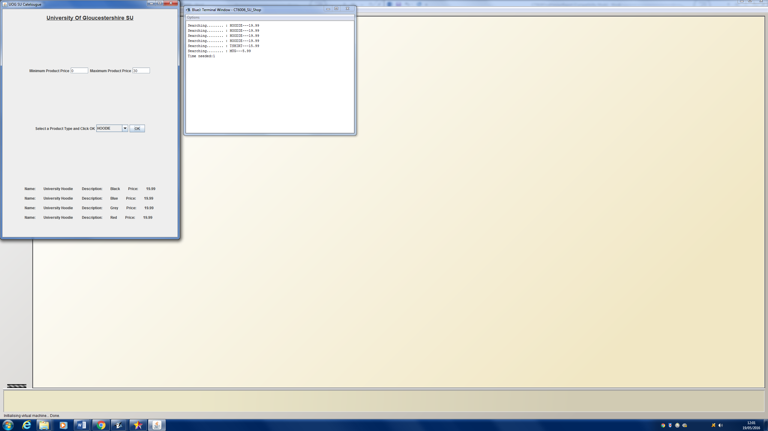

Figure 2 - screenshot showing the performance of the algorithm when making a search

Fig 22 shows a search being made and the performance of the algorithm being calculated. The dataset was too small to test originally so extra test data was added and the total amount of data was multiplied by 1000 to be able to test the algorithms true performance.

# Software Conclusions

The conclusions gained from creating the software following the adopted programming approaches outlined and discussed throughout the report has enabled the software to be created to carry out the required functionality through the use of an appropriate algorithm to execute the software functionality. The software has disadvantages due to certain limitations and constraints to the system which would be implemented differently if the software was to be improved in the future. The table 18 below outlines the improvements that would be added to the system in future version releases.

Table - Improvements to the system

|  |
| --- |
| Improvements to the system |
| Programming languages – the software was programmed mainly in Java which is imperative in the future the code would include Scala and prolog.  Data Storage – the system currently uses dummy data stored within functions in the system. The system in the future could include improved storage from a database or file based  Functionality – the software only gives users the ability to search for products within a category that fall between the user’s minimum and maximum price range. The system in the future could include additional functionality such as ability to set up an account, login for different user levels, and ability for payment of items. |

# 10. References

A.Lewis, G., Mahatham, T. and Wrage, L. (2016). *Assumptions Management in Software Development*. 1st ed. [ebook] pp.3-10. Available at: http://www.sei.cmu.edu/reports/04tn021.pdf [Accessed 17 May 2016].

C2.com. (2016). *Logic Programming*. Available at: http://c2.com/cgi/wiki?LogicProgramming [Accessed 17 May 2016].

Cs.drexel.edu. (2016). Available at: https://www.cs.drexel.edu/~introcs/Fa15/notes/06.1_OOP/Advantages.html?CurrentSlide=3 [Accessed 17 May 2016].

correctly, s. (2016). *set and get: what they are and how to use these methods correctly - Progressive Java .net*. Progressivejava.net. Available at: http://www.progressivejava.net/2012/12/set-and-get-what-they-are-and-how-to-use-these-methods-correctly.html [Accessed 19 May 2016].

Docs.oracle.com. (2016). *Declaring Member Variables (The Java™ Tutorials > Learning the Java Language > Classes and Objects)*. Available at: https://docs.oracle.com/javase/tutorial/java/javaOO/variables.html [Accessed 17 May 2016].

Docs.oracle.com. (2016). *Declaring Member Variables (The Java™ Tutorials > Learning the Java Language > Classes and Objects)*. Available at: https://docs.oracle.com/javase/tutorial/java/javaOO/variables.html [Accessed 17 May 2016].

Docs.oracle.com. (2016). *Using JAR Files: The Basics (The Java™ Tutorials > Deployment > Packaging Programs in JAR Files)*. Available at: https://docs.oracle.com/javase/tutorial/deployment/jar/basicsindex.html [Accessed 17 May 2016].

Docs.oracle.com. (2016). *EventHandler (Java Platform SE 7)*. Available at: https://docs.oracle.com/javase/7/docs/api/java/beans/EventHandler.html [Accessed 19 May 2016].

Docs.oracle.com. (2016). *How to Write an Action Listener (The Java™ Tutorials > Creating a GUI With JFC/Swing > Writing Event Listeners)*. Available at: https://docs.oracle.com/javase/tutorial/uiswing/events/actionlistener.html [Accessed 19 May 2016].

dzone.com. (2016). *ArrayList vs. LinkedList vs. Vector - DZone Java*. Available at: https://dzone.com/articles/arraylist-vs-linkedlist-vs [Accessed 17 May 2016].

Ibm.com. (2016). *IBM Knowledge Center*. Available at: http://www.ibm.com/support/knowledgecenter/ssw_aix_72/com.ibm.aix.performance/advantages_java.htm [Accessed 17 May 2016].

Javacoffeebreak.com. (2016). *Q&A: What is the difference between public, private, and protectedvariables?*. Available at: http://www.javacoffeebreak.com/faq/faq0002.html [Accessed 19 May 2016].

Javarevisited.blogspot.co.uk. (2016). *Why getter and setter are better than public fields in Java*. Available at: http://javarevisited.blogspot.co.uk/2012/12/getter-and-setter-method-vs-public-modifier-field-java.html [Accessed 19 May 2016].

Javarevisited.blogspot.co.uk. (2016). *10 Tips to override toString () method in Java - ToStringBuilder Netbeans Eclipse*. Available at: http://javarevisited.blogspot.co.uk/2012/09/override-tostring-method-java-tips-example-code.html## [Accessed 19 May 2016].

Javawithus.com. (2016). *Get and Set methods - Java Tutorial - Java With Us*. Available at: http://www.javawithus.com/tutorial/get-and-set-methods [Accessed 17 May 2016].

Justobjects.org. (2016). *Java Web Start - What*. Available at: http://justobjects.org/cowcatcher/browse/advjava/slides/java-dev-env/core/deploy/slide.0.13.html [Accessed 17 May 2016].

Marx, D. (2016). *Java toString () Considerations*. JavaWorld. Available at: http://www.javaworld.com/article/2073619/core-java/java-tostring---considerations.html [Accessed 19 May 2016].

Mkyong.com. (2009). *While loop, For loop and Iterator Performance Test – Java*. Available at: http://www.mkyong.com/java/while-loop-for-loop-and-iterator-performance-test-java/ [Accessed 19 May 2016].

Patil, M. (2016). *Overview of Java ArrayList, HashTable, HashMap, Hashet, LinkedList*. Mrbool.com. Available at: http://mrbool.com/overview-of-java-arraylist-hashtable-hashmap-hashetlinkedlist/30383 [Accessed 19 May 2016].

Shah, A. (2012). *Why and for What should I use Enum? Java Enum Examples • Crunchify*. Crunchify. Available at: http://crunchify.com/why-and-for-what-should-i-use-enum-java-enum-examples/ [Accessed 17 May 2016].

Softpanorama.org. (2016). *GUI vs Command line interface*. Available at: http://www.softpanorama.org/OFM/gui_vs_command_line.shtml [Accessed 19 May 2016].

Studytonight.com. (2016). *Search Algorithms: Linear and Binary Search | Data Structure Tutorial | Studytonight*. Available at: http://www.studytonight.com/data-structures/search-algorithms [Accessed 19 May 2016].

Top.idownloadnew.com. (2016). *4 programming paradigms | The best sites in the world*. Available at: http://top.idownloadnew.com/4_programming_paradigms/ [Accessed 17 May 2016].

Wikipedia. (2016). *Comparison of programming paradigms*. Available at: https://en.wikipedia.org/wiki/Comparison_of_programming_paradigms [Accessed 17 May 2016].

www.tutorialspoint.com. (2016). *Scala - Overview*. Available at: http://www.tutorialspoint.com/scala/scala_overview.htm [Accessed 17 May 2016].

www.tutorialspoint.com. (2016). *SDLC - Waterfall Model*. Available at: http://www.tutorialspoint.com/sdlc/sdlc_waterfall_model.htm [Accessed 17 May 2016].

Xyzws.com. (2016). *What is the advantage of using an Iterator compared to the get (index) method?*. Available at: http://www.xyzws.com/javafaq/what-is-the-advantage-of-using-an-iterator-compared-to-the-getindex-method/19 [Accessed 17 May 2016].

# Appendix A – Software Screenshots

Figure 23 shows the application interface when loaded by the user all GUI text fields and dropdown boxes load initially blank as a user has not made any selections yet.

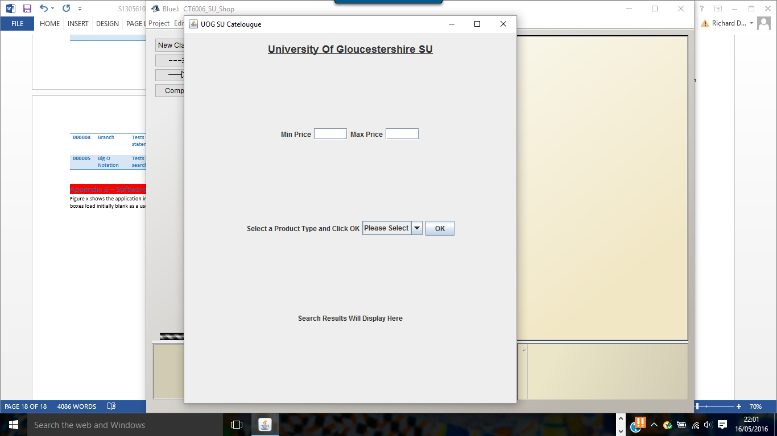

Figure 23 - Initial Load of System

Figure 24 shows the user interacting with the interface to enter a minimum price.

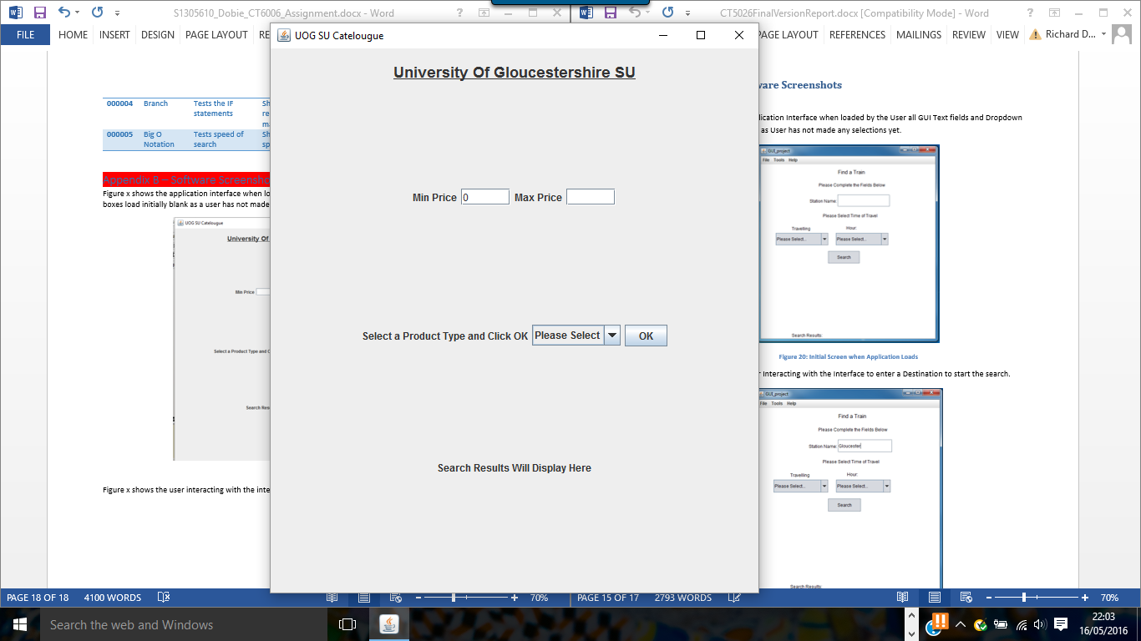

Figure 24 - Enter Minimum Price

Figure 25 shows the user interacting with the interface to enter a maximum price

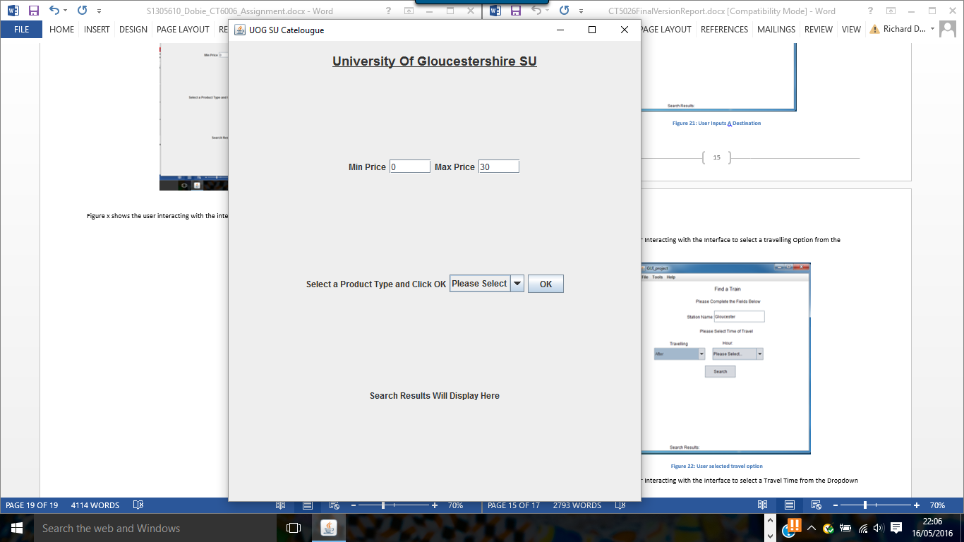

Figure 25 - Enter Maximum Price

Figure 26 shows the user interacting with the interface to select a product category from the dropdown list

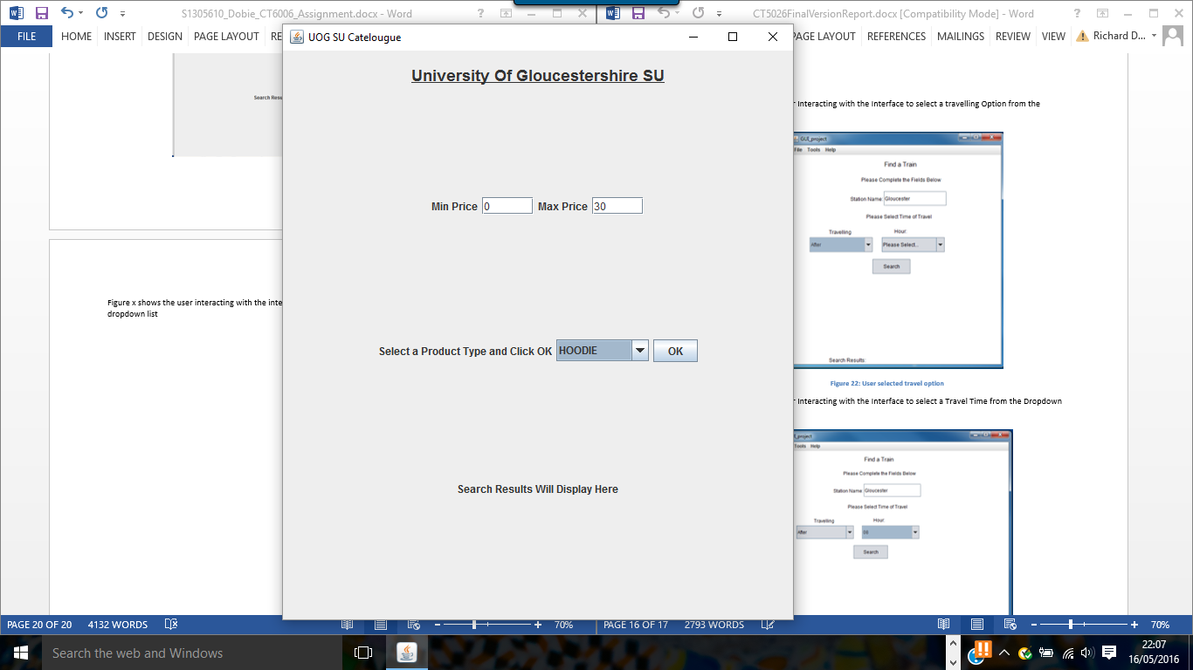

Figure 26 - Select Product Category

Figure 27 shows the user interacting with the interface to make a search and the interface has returned appropriate results.

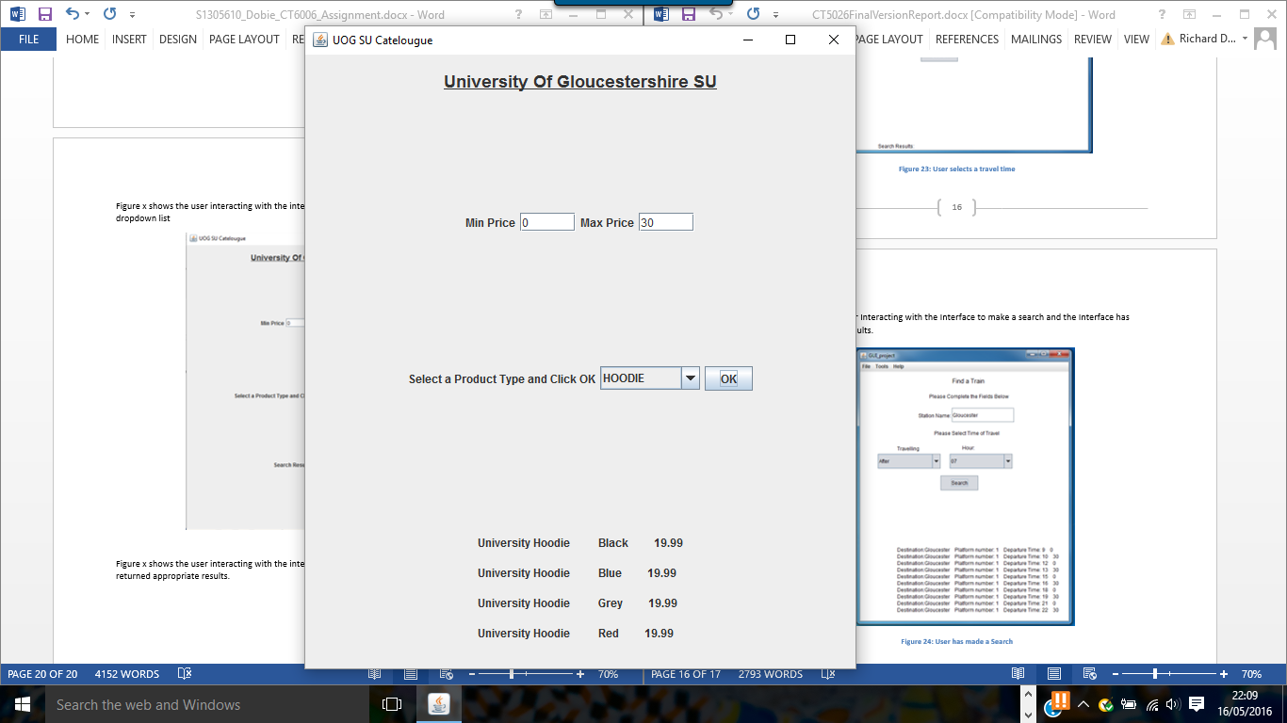

Figure 27 - Search Results

Figure 28 shows the user having made a search which doesn’t return any results. The system displays a message to the user telling them no results found. 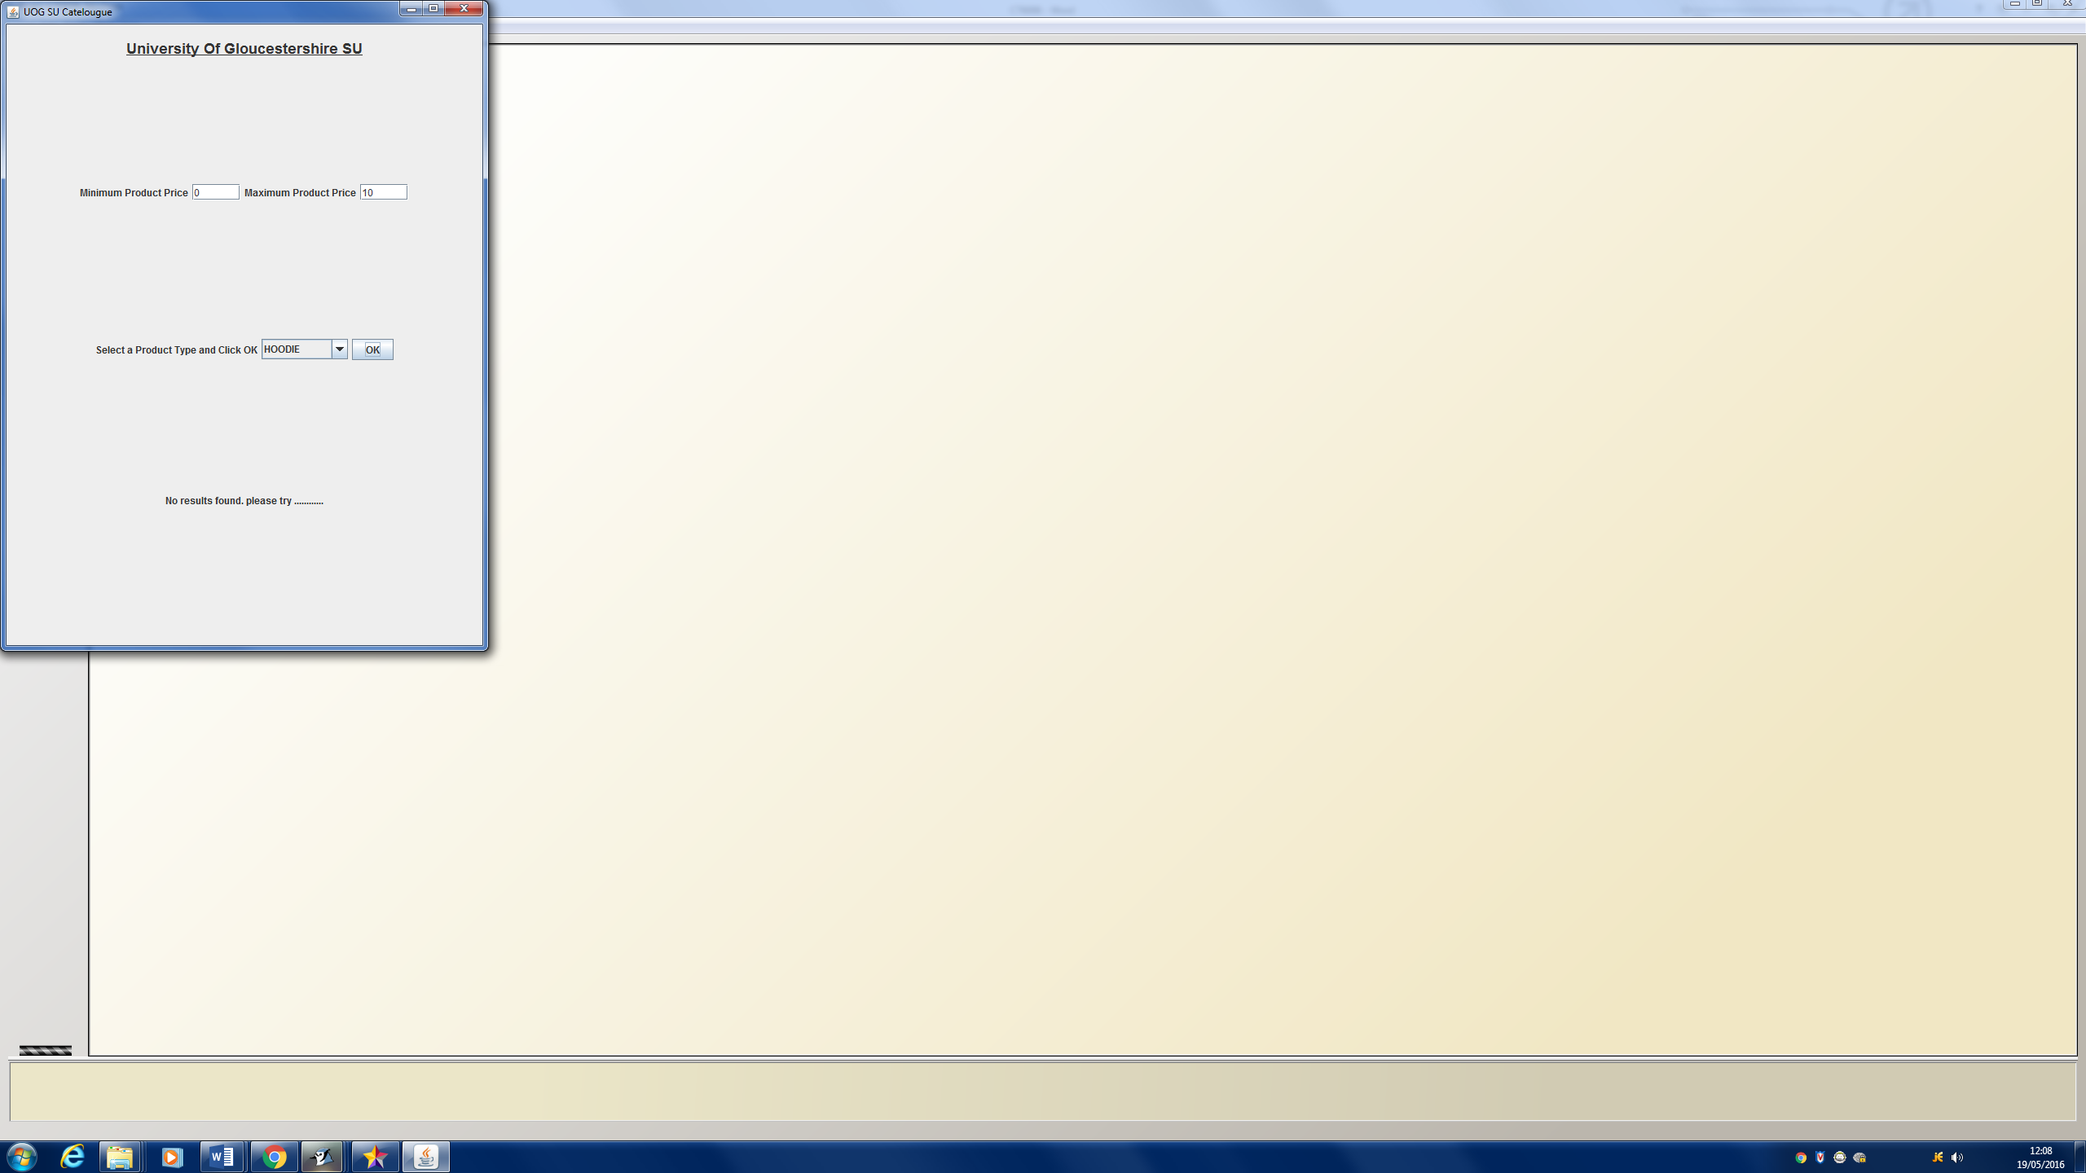

Figure 28 - No search results found